A guide to developing a mosquito management plan for Local Government

Part A – Template and guidance notes

Foreword
The need for a mosquito management plan (MMP) is usually triggered by a known or potential risk of mosquito nuisance and/or increased mosquito-borne disease activity. This template has been prepared to provide assistance to local government (LG) in the preparation of a MMP and should be used in conjunction with Part B: Case Study Examples. The structure of this document includes template headings followed by a brief description of the type of information that could be included under each section. Specific case study examples detailing the type of information that may be included can be found in Part B: Case Study Examples.
This document is intended to be used as a guide only and should be altered according to each LG’s unique requirements. It may be more appropriate to change the template headings themselves to ensure terminology is consistent with that used by the LG, alter the heading order based on the LG’s priorities, and/or remove template headings altogether if they are not required.
For new programs, an initial baseline investigation must be carried out to provide evidence to support the need for a MMP. This may only take a few weeks and will assist with developing a general idea of the types of problems being faced, and the potential management strategies to be employed. This initial investigation should try to answer a few basic questions including:
- what species of mosquitoes are present in the area?
- what types of environmental events or triggers lead to mosquito breeding?
- where are the major breeding sites?
This initial investigation will involve some basic ground work (e.g. adult and larval mosquito monitoring over a few weeks), as well as some investigative research. The research component may involve using aerial photography/Google Earth to assist with locating and mapping potential breeding sites, contacting other agencies such as the Department of Health (the Department) and/or nearby LGs who may be able to provide some further information, establishing land ownership/responsibilities/required permits for accessing sites and monitoring environmental conditions that influence mosquito and associated virus activity, such as rainfall/tides/air temperature/water temperature.
The issue of mosquito management is complex. This document assumes the user has a reasonable knowledge of mosquito management, as it is simply not possible to include all the background information required to prepare and implement a robust MMP within this summary document. It may be useful to refer to the Department’s most current Mosquito Management Manual for more detailed information when preparing a MMP or refer the mosquito management related content on the Department’s website.
MMPs will vary markedly from one LG to another depending on their intended use and the scale of the program. Some considerations that may assist with guiding the style of the document and keeping it focused include:
- What is the purpose of the MMP (i.e. document a program already in place to assist with corporate knowledge retention or inform the development of a new mosquito management program)?
- Are developments being proposed that will potentially lead to new mosquito problems (nuisance and/or disease risk) that have not been previously assessed and/or managed?
- Are you seeking internal and/or ongoing (financial) support for your program?
- Do you have potential mosquito breeding sites and you want to be prepared?
- Is the MMP a requirement for planning approval?
- Is the MMP site specific or does it encompass all sites within the LG’s jurisdiction?
- Who is the audience (i.e. internal document and/or a modified summary for the public)?
- Will it be beneficial to divide the MMP into two documents to provide an overarching plan and a more detailed procedure manual?
Where possible, keep the MMP short and to the point. It is important that this document is easy to follow, particularly if the purpose of the MMP is for knowledge retention and to guide day-to-day activities.
Contents Page
1.0 Introduction/executive summary 3
2.0 Program objectives 3
3.0 Strategic implications 3
4.0 Statutory management and legislation 3
5.0 Mosquito biology and ecology 3
6.0 Breeding sites 4
7.0 Nuisance/disease risk 4
8.0 Baseline survey/existing data 4
8.1 Adult and larval mosquito monitoring 5
8.2 Environmental data 5
9.0 Mosquito management strategies 5
10.0 Ongoing monitoring and surveillance 6
11.0 Public education 6
12.0 Stakeholders 6
12.1 Internal stakeholders 6
12.2 External stakeholders 6
13.0 New developments 7
14.0 Record keeping 7
15.0 Budget and resource requirements 8
16.0 Training and staff development 8
17.0 Procedure manual 8
18.0 Review of mosquito management plan 8

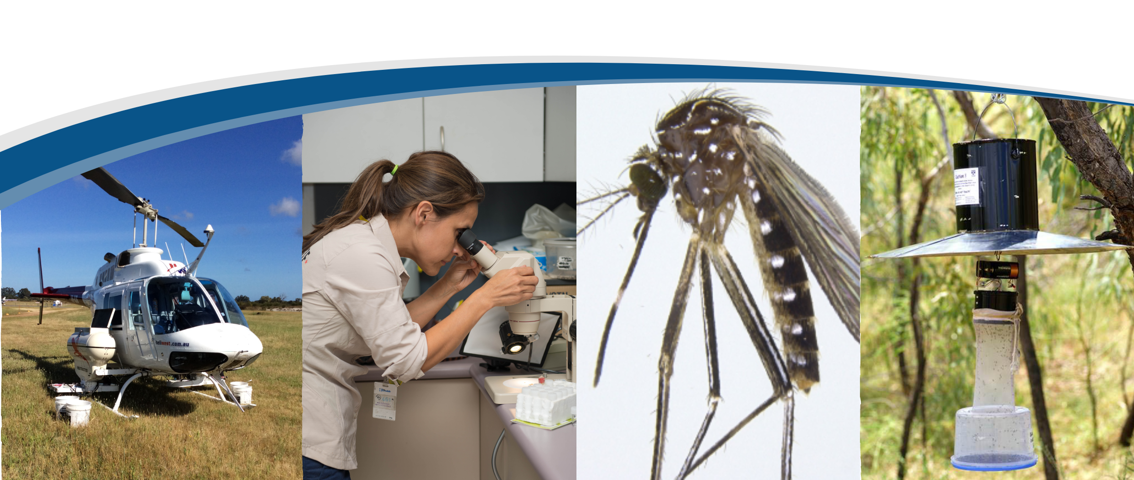

Template and guidance notes

Introduction/executive summary
It may be useful to include a one-page summary outlining the need for a MMP at the beginning of the document to use as a quick reference tool. The amount of information required here will vary between LGs. This section should be focused and avoid unnecessary descriptions. See page 3 of Part B for specific examples.
This section might include general information about:
- population;
- tourism impacts;
- general mosquito nuisance and/or disease issues;
- types of mosquito breeding sites (e.g. tidal/rainfall influenced; naturally occurring/constructed water bodies; stormwater infrastructure/sewage lagoons);
- geographical description (physical environment/climate); and
- location of breeding sites (via maps/aerial photography).

Program objectives
This section is designed to keep the MMP focused. Including written objectives in dotpoint form will help you to achieve this. See page 4 of Part B for specific examples.

Strategic implications
This section should be used to link the MMP to your LG strategic plan or public health planning objectives. This will be particularly important for gaining ongoing internal support and resources for the MMP. See page 5 of Part B for specific examples.

Statutory management and legislation
There is legislation/policy in place that may govern what you should, can and cannot do. It is the responsibility of the LG to ensure any necessary approvals relating to mosquito management are obtained before management actions are carried out. See page 5 of Part B for specific examples.

Mosquito biology and ecology
Include a brief background information on mosquitoes and associated disease risks if it will benefit the reader by improving their general knowledge in this area. This may include information on:
- lifecycle;
- breeding habitats; and
- nuisance and vector species and associated diseases of relevance to the LG.
This section may not be necessary for all LGs. Alternatively, the information may be provided within other sections of the document (e.g. introduction, disease risk etc). See page 6 of Part B for specific examples.

Breeding sites
This section is used to briefly define significant breeding sites within the LG jurisdiction. It may also be necessary to inform the reader of significant issues relating to certain breeding sites such as land ownership and third parties responsible for the land. Detailed descriptions of individual breeding sites could be provided in a separate document (Procedure Manual or similar), with a reference to that document included here. See page 6 of Part B for specific examples.

Nuisance/disease risk
This section provides evidence for why the LG needs to undertake mosquito management. The data provided here will assist with gaining ongoing internal support and resources to implement the MMP.
For existing/well established programs, this section will simply summarise information that has been gathered steadily over time. All existing mosquito information relating to nuisance complaints and notified disease cases should be summarised here. This could include general comments on:
- Public complaints: Summarise where and when the majority of mosquito nuisance complaints originate from. Maps pinpointing complaints are often useful here.
- Adult trap results: Include average trap numbers/dominant species/disease vector data. More detailed adult trap information may be included as an appendix or provided in other documents (e.g. annual report). Discussion should be limited to the impact that the number of mosquitoes and/or presence of vector species has on nuisance and disease risk.
- Notified (locally acquired) mosquito-borne disease case data: Locally acquired, notified cases of mosquito-borne disease can be used to highlight the public health risk associated with mosquitoes. If this information is not available within the LG’s records, the Department will be able to provide this information (including long term data/average attack rates etc).
- Virus detection data: This information may be available from the Department if they have carried out surveillance work in your region. This is particularly relevant from those LGs located between Mandurah and Busselton.
For new management programs there may be little information available. Generally speaking, the need for preparing a MMP stems from either large numbers of mosquito complaints or large numbers of notified cases of a mosquito-borne disease. For new programs, this information can be included here, with the clause that further investigation will be carried out to assess the risk and define the extent of the problem.
Other general statements about nuisance and disease risk in the greater region may be relevant if the LG is able to obtain this information from neighbouring jurisdictions with established management programs. The Department may also be able to provide some general advice related to this section. See page 7 of Part B for specific examples.

Baseline survey/existing data
Like many other sections of the MMP, the information provided here will be different for a LG that has been carrying out mosquito management for a long time compared with a LG developing a new program or extending their program as the result of a new development.
Existing programs will report on the findings from previous baseline investigations and/or the results of ongoing monitoring and surveillance.
New programs may propose what needs to be carried out to undertake a baseline survey, reporting on baseline investigations or outlining a plan for future mosquito monitoring and surveillance.
Baseline investigations are very important when establishing a new program or assessing the risk of mosquito nuisance and mosquito-borne disease in new developments. The data obtained will be used to inform initial control strategies and compare future surveys against when assessing the impact of management activities. See page 8 of Part B for specific examples.

Adult and larval mosquito monitoring
The baseline investigation should include regular adult and larval monitoring at permanent locations. Standard operating procedures on how to undertake adult mosquito trapping and mosquito identification can be accessed on the Department’s website.
The frequency of sampling will vary depending on the type of breeding sites and what the triggers for breeding may be. As a general guide, weekly larval and fortnightly adult monitoring should be undertaken over the average mosquito breeding season. This can be reduced to fortnightly larval and monthly adult monitoring over the off-season. In the southern third of WA the average mosquito breeding season is approximately August to April. In the north of WA, the average mosquito breeding season will coincide with the wet season (usually January to May). The larval monitoring regime may be altered as you become more aware of environmental triggers (see below).

Environmental data
The collection of environmental data that may affect mosquito breeding, including rainfall, tide and temperature, plays a critical role in the baseline investigation. This information (and other factors such as change in vegetation, water quality etc) should be correlated with the larval and adult sampling results and reported here. Overtime, these correlations will enable a more robust sampling regime to be developed and breeding triggers to be identified. It may also inform the timing of larval monitoring (See page 8 of Part B).
The baseline investigation should last at least 12 months, to monitor seasonal changes to mosquito habitats. This should be sufficient to allow initial control strategies to be developed. If this work is being undertaken to assess the risk of mosquito nuisance and/or mosquito-borne disease for new developments, a longer period of investigation of three years or more will account for seasonal changes both within the year and from one year to the next.
Longer baseline investigations over two to three years are particularly beneficial in observing variation in mosquito breeding habitat over time. Control strategies can be adapted to accommodate for this variation and monitored for effectiveness. For example, a LG may only experience minimal mosquito breeding (e.g. in containers and drains etc) in years where environmental conditions are average, but may be subject to substantial flooding and mosquito breeding after cyclones every three or four years. Similarly, those LGs whose breeding sites are tidally driven may have very few mosquitoes from year to year, whilst environmental conditions are favourable. This may dramatically change when La Niña conditions favour extremely high tides and mosquito breeding becomes extensive. See page 8 of Part B for specific examples.

Mosquito management strategies
Provide a summary of the proposed strategies to manage mosquitoes here. This may include some general information about chemical, cultural, biological and/or physical management methods being used, and the importance of an integrated management program. For small programs, more site-specific information such as the rationale for chosen methods at a particular location could be included here, while larger scale programs could include this information in a separate document such as a Procedure Manual. See page 9 of Part B for specific examples.

Ongoing monitoring and surveillance
Once management strategies have been implemented, it is essential that ongoing monitoring and surveillance is carried out. This work is critical to the overall program and will enable:
- timely decisions to be made regarding when management strategies need to be implemented;
- effectiveness of management strategies to be assessed;
- known breeding sites to be further defined; and
- identification of potential new breeding sites.
Ongoing monitoring and surveillance should be carried out in a similar manner to the baseline data investigation, with standard sites regularly sampled for comparison. Larval, adult and environmental conditions should all form part of the ongoing monitoring program. Over time, this will enhance the knowledge of mosquito ecology within the area, providing a clearer understanding of the way populations change over time in response to environmental variables. This information can then be incorporated into updated versions of the MMP during the review process. See page 10 of Part B for specific examples.

Public Education
Public education is now recognised as playing an important role in integrated mosquito management. This section is likely to focus on LG efforts to raise awareness of mosquitoes, mosquito-borne disease and personal prevention strategies among the general public. Many LGs are utilising the state-wide Fight the Bite campaign in order to do this. This section may document social media activities, advertising and passive/active community engagement efforts. LGs may have developed a separate communication plan that can be referred to here.

Stakeholders
Effective mosquito management requires consultation and collaboration with a range of internal and external stakeholders. This section can be used to identify all parties that may need to be consulted in regards to mosquito management within the LG jurisdiction and/or ensuring the MMP can be executed effectively.

12.1 Internal stakeholders
In most cases, mosquito management becomes the responsibility of the LG’s Environmental Health section. However, it is critical that there is an internal working relationship between the Environmental Health team and other sections of the LG, including Planning (land-use development) and Engineering (water management). This will ensure all parties within the LG consider the potential for mosquito breeding and the mosquito management implications when approving development applications and managing infrastructure. See page 10 of Part B for specific examples.

12.2 External stakeholders
At times, external parties play a role in ensuring the MMP is effective. This is particularly important in areas where mosquitoes may cross borders from one LG to another. Where LGs sharing common borders and a common mosquito problem agree to work in partnership to manage mosquitoes, they may be able to form a CLAG (Contiguous Local Authority Group). This enables the LGs to receive ongoing support and financial assistance from the Department to assist their mosquito management program. Further information on CLAG formation can be found on the Department’s website.
Furthermore, external stakeholders may be responsible for land within the LG area where mosquito breeding is problematic (e.g. Water Corporation; Department of Biodiversity, Conservation and Attractions, Department of Planning, Lands and Heritage). These stakeholders should be approached to determine their capacity to undertake mosquito management. If this is not possible, discussions will be required regarding access to land for surveillance and possible treatment, as well as budgetary requirements for undertaking mosquito management on behalf of external stakeholders. See page 10 of Part B for specific examples.

New developments
New developments can significantly impact a MMP. It is therefore critical for the Planning and Environmental Health teams within a LG to discuss development applications and consider the mosquito management implications prior to the approval process being finalised.
New developments are likely to require consideration within a MMP if residents will be located within close proximity (within 3km) to natural mosquito breeding habitat, or if the development itself will create additional mosquito problems through the introduction of constructed water bodies and other water holding infrastructure. Both can significantly impact on the mosquito management budget and required resourcing.
There needs to be clear decisions made about who is responsible for mosquito management within a new land development (e.g. the developer/land owner or the LG). The LG needs to clearly communicate any recommendations and/or requirements that will reduce the potential impact of mosquitoes on new residents, as part of the development approval process. In some cases, the developer may be responsible for a period of time (three to five years), after which the responsibility is handed over to the LG. Conflict can arise when mosquitoes breeding on land owned and managed by the LG affects new residents. If it is evident that mosquito management will not be effective or feasible, then the development may need to be reconsidered altogether.
For development areas where the risk of mosquito nuisance and/or mosquito-borne disease is not clearly defined, then as a minimum, a baseline investigation (as per section 8) should be undertaken. This work needs to be carried out over a minimum of 12 months (preferably three years or more) to establish changing patterns in mosquito abundance over time, in response to seasonal variation. Consideration needs to be given to who will undertake the baseline investigation as it is important to ensure the work is carried out by appropriately trained personnel. The developer may fund an investigation undertaken by the LG or an out-sourced, external consultant.
For areas where the risk of mosquito nuisance and/or mosquito-borne disease has been clearly defined, a MMP may be a requirement prior to the initiation of the development. The MMP needs to clearly indicate who will be responsible for implementing and resourcing the plan. Some LGs absorb the cost of this work within existing budgets (cutting funds from other programs), while others require the developer to contribute financially to mosquito management. See page 11 of Part B for specific examples.

Record keeping
Maintaining ongoing records is another critical component of a MMP. This documentation (e.g. adult and larval monitoring, nuisance complaints, environmental data etc) enables long term data to be recorded and analysed to further enhance the MMP. This section may be used as a reference point as to where to keep and maintain records relating to mosquito management. Production of an annual report is a useful means of communicating current and/or changing knowledge in relation to mosquito management and can assist in the regular review of the MMP. This section could be used as a reference point for locating the annual report. CLAGs have a formal requirement to complete and submit an annual report to the Department each year, in order to access CLAG funding. An annual report template is available on request. See page 12 of Part B for specific examples.

Budget and resource requirements
This section can be used to outline any resources required to ensure the MMP is effective. Some LGs may choose to provide a general statement of the personnel, vehicles and equipment required here, while others opt for a more detailed breakdown of these items and their associated costs. Detail may be provided in a separate document such as a Procedure Manual if you wish to keep the MMP more concise. It may be advisable to include a clause stating that due to environmental variations from year to year; the budget will need to be dynamic and adjusted according to the current season. See page 12 of Part B for specific examples.

Training and staff development
This section should be used to gain support for training of staff members. It should be noted here that it is essential for more than one person to be trained in mosquito management (this may include staff other than environmental health officers, such as depot and/or parks and garden staff) to ensure effective mosquito management continues to be undertaken if the lead officer is ill or on annual leave. Having more than one person trained also allows for retention of corporate knowledge if one staff member was to leave before being able to handover to the next person appointed to that role. See page 13 of Part B for specific examples. The Department runs a series of mosquito identification and management related courses that are highly recommended for staff to attend who are new to mosquito management.

Standard operating Procedure (SOP) manual
Rather than include the finer details of mosquito management in this document, some LGs prefer to include more detailed information relating to the day-to-day running of the program in a separate document such as a SOP Manual. Other LGs prefer to have one all-encompassing document with the more detailed information spread throughout the MMP. This section is only appropriate if a SOP Manual has been produced and can be used to direct the reader to where they can find the document. See page 13 of Part B for specific examples. The Department has published information on a range of mosquito management related topics (eg. EVS/CO₂ trapping), in SOP format, that LG may wish to refer to in this process.

Review of mosquito management plan
The MMP will need to be regularly reviewed, particularly for new programs where management strategies have not yet been evaluated.
New MMPs may need to be reviewed and amended on an annual basis for the first three years to allow for the incorporation of seasonal variation and to adjust management strategies as trends begin to emerge over time.
For established programs, the MMP may only need to be reviewed every three to five years. This may need to be sooner if new breeding sites are identified, new developments are proposed or new management strategies become available for use. See page 13 of Part B for specific examples.

Contact us:

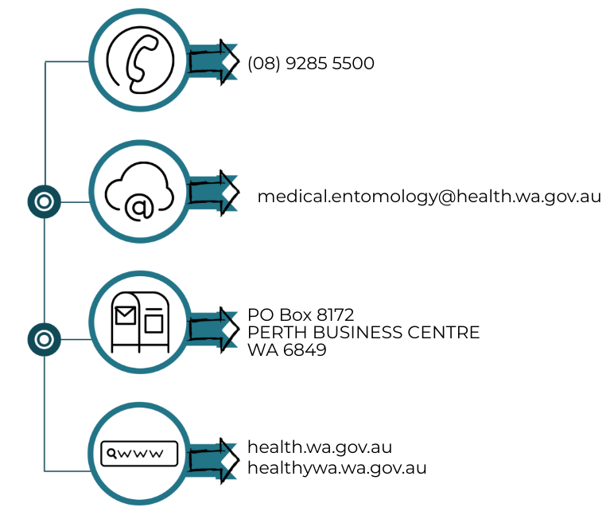

This document can be made available in alternative formats
on request for a person with disability.
© Department of Health 2020
Copyright to this material is vested in the State of Western Australia unless otherwise indicated. Apart from any fair dealing for the purposes of private study, research, criticism or review, as permitted under the provisions of the Copyright Act 1968, no part may be reproduced or re-used for any purposes whatsoever without written permission of the State of Western Australia.

