Foodborne disease surveillance and outbreak investigations in Western Australia, second quarter 2016

**Enhancing foodborne disease surveillance across Australia**



**Communicable Disease Control Directorate**



OzFoodNet, Communicable Disease Control Directorate

**Acknowledgments**

Acknowledgement is given to the following people for their assistance with the activities described in this report: Mr Damien Bradford, Ms Lyn O’Reilly, Ms Marilina Chiari and the staff from the enteric, PCR and food laboratories at PathWest Laboratory Medicine WA; Mr John Coles and other staff from the Food Unit of the Department of Health, Western Australia; Public Health Nurses from the metropolitan and regional Population Health Units; and Local Government Environmental Health Officers.

**Contributors/Editors**

Barry Combs, Nevada Pingault and Niki Foster

Communicable Disease Control Directorate

Department of Health, Western Australia

PO Box 8172

Perth Business Centre

Western Australia 6849

Email: [OzfoodnetWA@health.wa.gov.au](mailto:OzfoodnetWA@health.wa.gov.au)

Telephone: (08) 9388 4999

Facsimile: (08) 9388 4877

Web:

OzFoodNet WA Health [www.public.health.wa.gov.au/3/605/2/ozfoodnet_enteric_infections_reports.pm](http://www.public.health.wa.gov.au/3/605/2/ozfoodnet_enteric_infections_reports.pm)

OzFoodNet Department of Health

[www.ozfoodnet.gov.au/](http://www.ozfoodnet.gov.au/)

**Disclaimer**:

Every endeavour has been made to ensure that the information provided in this document was accurate at the time of writing. However, infectious disease notification data are continuously updated and subject to change.

This publication has been produced by the **Department of Health, Western Australia**.

# Executive summary

During the second quarter of 2016, the Western Australian (WA) OzFoodNet team conducted surveillance of enteric diseases, undertook investigations into outbreaks and was involved with ongoing enteric disease research projects.

The most common notifiable enteric infections in WA were campylobacteriosis (n=759), salmonellosis (n=451), cryptosporidiosis (n=71) and rotavirus infection (n=27) (Figure 1). Notifications of campylobacteriosis and salmonellosis were 47% and 41% higher, respectively than the 5-year second quarter mean, while rotavirus and cryptosporidiosis notifications were lower. The large increase in salmonellosis was driven by an increase in notifications of *S*. Typhimurium PFGE 0001.

Three foodborne outbreaks were investigated in the first quarter, with two due to *Salmonella* and associated with the consumption of raw egg dishes.

OzFoodNet also conducted surveillance of 17 non-foodborne outbreaks and most (n=10) were in aged care facilities. Of these, the most common mode of transmission was person-to-person (13 outbreaks), with a total of 203 people ill. Norovirus was most commonly report pathogen in these outbreaks (identified in 5 outbreaks).

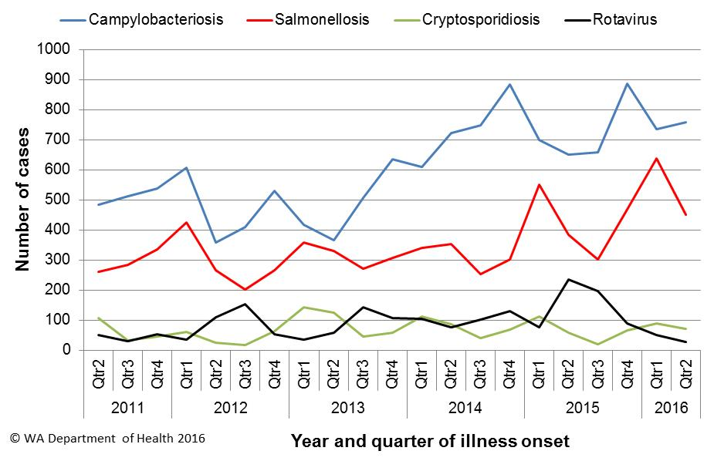

Figure 1 Notifications of the four most common enteric diseases by quarter from 2011 to 2016, WA

**Table of Contents**

Executive summary 2

1 Introduction 5

2 Incidence of notifiable enteric infections 6

2.1. Methods 6

2.2. Campylobacteriosis 6

2.3. Salmonellosis 7

2.4. Cryptosporidiosis 8

2.5. Rotavirus infection 9

2.6. Other enteric diseases and foodborne illness 10

3 Foodborne and probable foodborne disease outbreaks 11

3.1. Residential care facility, *Clostridium perfringens* (outbreak code 05/16/MMR) 11

3.2. Dinner Party outbreak, *Salmonella* Typhimurium (outbreak code 042-2016-012) 12

3.3. Café outbreak, *Salmonell*a Typhimurium (outbreak code 042-2016-006) 12

4 Cluster investigations 13

4.1. *Salmonella* Typhimurium PFGE 0001, PT 9 13

4.2. *Salmonella* Typhimurium MLVA 04-14-00-00-463 14

4.3 *Salmonella* Typhimurium MLVA 03-12-13-08-523 14

4.4 *Salmonella* Newport 14

5 Non-foodborne disease outbreaks and outbreaks with an unknown mode of transmission 15

5.1. Person-to-person outbreaks 15

5.2. Outbreaks with unknown mode of transmission 16

5.2.1 Rural caravan park, STEC (Outbreak code 088-2016-001) 16

6 Site activities 16

7 References 17

**List of Tables**

Table 1 Number of campylobacteriosis notifications, 2nd quarter 2016, WA, by region 7

Table 2 Number of salmonellosis notifications, 2nd quarter 2016, WA, by region 8

Table 3 Number of cryptosporidiosis notifications, 2nd quarter 2016, WA, by region 9

Table 4 Number of rotavirus notifications, 2nd quarter 2016, WA, by region 9

Table 5 Summary of number of notified cases of enteric notifiable diseases in WA in the second quarter 2016 compared to historical means 11

Table 6 Outbreaks with non-foodborne transmission, 2nd Quarter 2016, WA 15

**List of Figures**

Figure 1 Notifications of the four most common enteric diseases by quarter from 2011 to 2016, WA 2

Figure 2 Notifications of *Salmonella* Typhimurium PFGE 0001 in WA, 2012 to June 2016 14

**Notes:**

1. All data in this report are provisional and subject to future revision.
2. To help place the data in this report in perspective, comparisons with other reporting periods are provided. As no formal statistical testing has been conducted, some caution should be taken with interpretation.

Copyright to this material is vested in the State of Western Australia unless otherwise indicated. Apart from any fair dealing for the purposes of private study, research, criticism or review, as permitted under the provisions of the Copyright Act 1968, no part may be reproduced or re-used for any purposes whatsoever without written permission of the State of Western Australia.

# Introduction

It has been estimated that there are 5.4 million cases of foodborne illness in Australia each year at a cost of $1.2 billion per year1. This is likely to be an underestimate of the total burden of gastrointestinal illness as not all enteric infections are caused by foodborne transmission. Other important modes of transmission include person-to-person, animal-to-person and waterborne transmission. Importantly, most of these infections are preventable through interventions at the level of primary production, commercial food handling, households and institution infection control.

This report describes enteric disease surveillance and investigations carried out during the second quarter of 2016 by OzFoodNet WA, other WA Department of Health (WA Health) agencies and local governments. Most of the data are derived from reports by doctors and laboratories to WA Health of 16 notifiable enteric diseases. In addition, outbreaks caused by non-notifiable enteric infections are also documented in this report, including norovirus, which causes a large burden of illness in residential (mostly aged) care facilities (RCF) and the general community.

OzFoodNet WA is part of the Communicable Disease Control Directorate (CDCD) within WA Health, and is also part of the National OzFoodNet network funded by the Commonwealth Department of Health2. The mission of OzFoodNet is to enhance surveillance of foodborne illness, including investigating and determining the cause of outbreaks. OzFoodNet also conducts applied research into associated risk factors and develops policies and guidelines related to enteric disease surveillance, investigation and control. The OzFoodNet site based in Perth is responsible for enteric disease surveillance and investigation in WA.

OzFoodNet WA regularly liaises with staff from: Public Health Units (PHUs); the Food Unit in the Environmental Health Directorate of WA Health; and the Food Hygiene, Diagnostic and Molecular Epidemiology laboratories at PathWest Laboratory Medicine WA.

PHUs are responsible for a range of public health activities, including communicable disease control, within their respective administrative regions. The PHUs monitor RCF gastroenteritis outbreaks and provide infection control advice. The PHUs also conduct follow-up of sporadic cases of important enteric diseases including typhoid, paratyphoid and hepatitis A.

The Food Unit liaises with Local Government (LG) Environmental Health Officers (EHO) during the investigation of food businesses. The Food Hygiene, Diagnostic and Molecular Epidemiology laboratories at PathWest Laboratory Medicine WA provide public health laboratory services for the surveillance and investigation of enteric disease.

# Incidence of notifiable enteric infections

## Methods

Enteric disease notifications were extracted from the Western Australian Notifiable Infectious Diseases Database (WANIDD) by optimal date of onset (ODOO) for the time period 1st April 2011 to 30th June 2016. The ODOO is a composite of the ‘true’ date of onset provided by the notifying doctor or obtained during case follow-up, the date of specimen collection for laboratory notified cases, and when neither of these dates is available, the date of notification by the doctor or laboratory, or the date of receipt of notification, whichever is earliest. Rates were calculated using estimated resident population data for WA from Rates Calculator version 9.5.5 (WA Health, Government of Western Australia), which is based on 2011 census data. Rates calculated for this report have not been adjusted for age.

## Campylobacteriosis

Campylobacteriosis was the most commonly notified enteric disease in WA during the second quarter of 2016 (2Q16), with 759 notifications and a rate of 114 cases per 100 000 population per year (Table 1). There was a 47% increase in campylobacteriosisnotifications in the 2Q16 compared with the 5-year mean of 516 notifications. The increase appeared to be due to sporadic disease, as there were no identified *Campylobacter* outbreaks during the 2Q16. At least some of the increase is likely to be due to the introduction by one large private pathology laboratory of polymerase chain reaction (PCR) testing of faecal specimens, which has greater sensitivity than culture techniques.

The place of acquisition of infection was reported for 57% (n=436) of cases, of which 82% (n=357) were locally acquired and 17% (n=75) were acquired overseas.

Table 1 Number of campylobacteriosis notifications, 2nd quarter 2016, WA, by region



**\***Percentage change in the number of notifications in the current quarter compared to the historical 5-year mean for the same quarter. Positive values indicate an increase when compared to the historical 5-year mean of the same quarter. Negative values indicate a decrease when compared to the historical 5-year mean of the same quarter. Percentage change should be interpreted with caution when the number of cases is small.

## Salmonellosis

Salmonellosis was the second most commonly notified enteric disease in WA in the 2Q16, with 451 notifications and a rate of 68 cases per 100 000 population per year (Table 2). The number of salmonellosisnotifications in the 2Q16 was 41% higher than the 5-year mean (n=319), with the increase occurring primarily in the Perth metropolitan and south-western corner of the state.

Place of acquisition of infection was reported for 77% (n=349) of cases, of which 66% (n=230) were locally acquired, 32% (n=113) were acquired overseas and 2% (n=6) were acquired interstate.

The most commonly reported *Salmonella* serotype was *S*. Typhimurium (STM) (n=181, 40%), and of those cases with information on place of acquisition (n=140, 77%), 91% of cases (n=189) were locally acquired. Pulsed-field gel electrophoresis (PFGE) was previously used for subtyping of STM in WA, but as of the beginning of 2016, multi locus variable number tandem repeat analysis (MLVA) has replaced PFGE. The most common MLVA types for 2Q16 were 03-25-16-11-523 (n=16, 9%), 03-10-15-11-496 (n=13, 7%), 03-26-16-11-523 (n=10, 6%) and 03-15-20-11-523 (n=10, 6%), all of which are analogous with PFGE 0001. There has been an ongoing community wide outbreak of PFGE 0001 in WA over the past two years (Section 4), including many identified point source outbreaks of this STM PFGE type (Section 3).

Table 2 Number of salmonellosis notifications, 2nd quarter 2016, WA, by region



**\***Percentage change in the number of notifications in the current quarter compared to the historical 5-year mean for the same quarter. Positive values indicate an increase when compared to the historical 5-year mean of the same quarter. Negative values indicate a decrease when compared to the historical 5-year mean of the same quarter. Percentage change should be interpreted with caution when the number of cases is small.

NA: not applicable as there is a 0 value in the calculation for the 2nd quarter % change

*S*. Enteritidis was the second most common *Salmonella* serotype (n=53, 12%), with most (n=51, 96%) cases acquired overseas, primarily after travel to Indonesia (n=35, 69%), and almost exclusively to Bali.

*Salmonella* Paratyphi B bv javawas the next most common serotype (n=16), with 50% of cases acquired overseas and 38% acquired in WA. There were also 16 notifications of *Salmonella* Saintpaul and most (63%) of these notifications were acquired in WA. In addition, there were 16 notifications of *Salmonella* that had no serotype. Most (63%) of these notifications were from one laboratory that first uses PCR screening for enteric pathogens. Specimens that are subsequently culture negative remain as a “PCR only” notification.

## Cryptosporidiosis

In the 2Q16 there were 71 cryptosporidiosis notifications (11 cases per 100 000 population per year), a 12% decrease compared to the 5-year mean (Table 3).

The place of acquisition of infection was reported for 75% (n=53) of cases of which 81% (n=43) were locally acquired.

Table 3 Number of cryptosporidiosis notifications, 2nd quarter 2016, WA, by region



**\***Percentage change in the number of notifications in the current quarter compared to the historical 5-year mean for the same quarter. Positive values indicate an increase when compared to the historical 5-year mean of the same quarter. Negative values indicate a decrease when compared to the historical 5-year mean of the same quarter. Percentage change should be interpreted with caution when the number of cases is small.

## Rotavirus infection

In the 2Q16 there were 27 notifications of rotavirus infection (4 cases per 100 000 population per year), a 77% decrease compared with the mean of the previous 4 years (Table 4). Notifications were predominantly seen in the Perth metropolitan area in the 2Q16. Of the cases with known Aboriginality status, most (96%) cases were non-Aboriginal. The median age was <1 year old (range <1 years to 79 years).

Table 4 Number of rotavirus notifications, 2nd quarter 2016, WA, by region



*Percentage change in the number of notifications in the current quarter compared to the historical 4-year mean for the same quarter. Positive values indicate an increase when compared to the historical 4-year mean of the same quarter. Negative values indicate a decrease when compared to the historical 4-year mean of the same quarter. Percentage change should be interpreted with caution when the number of cases is small.

**Rotavirus: comparison to four years (2012-2015) of data only because laboratory testing and notification practices (increased use of more specific PCR over antigen testing) have changed since the beginning of 2012.

NA: not applicable as there is a 0 value in the calculation for the 2nd quarter % change

## Other enteric diseases and foodborne illness

During the 2Q16, other enteric disease notifications included:

* **Shigellosis**: There were 20 shigellosis notifications in 2Q16 that were culture positive, which was 43% higher than the 5-year mean (n=14) (Table 5). *Shigella* *sonnei* was the most commonly notified species (14/20), with *S. sonnei* biotype A the most common subtype (8/14). Three cases of *S. flexneri,* two cases of *S. boydii* and one unspeciated *Shigella* casewere notified in 2Q16. Of the notified cases, four (20%) were Aboriginal people, 15 (75%) were non-Aboriginal people and Aboriginality status was unknown for one case. The place of acquisition of infection was reported for 60% (n=12), and 58% (n=7) were acquired overseas.
* **Hepatitis A infection:** Two hepatitis A cases were notified in 2Q16, with one case acquiring their infection overseas in Thailand. The second case acquired their illness in WA and had the same hepatitis A strain as the multijurisdictional outbreak strain (see <http://www.health.gov.au/internet/main/publishing.nsf/Content/ohp-hep-A-media-15-frozen-berry.htm>). This recent case had also eaten frozen berries from a WA supplier.
* **Hepatitis E infection:** One case in an adult male who had travelled to India.
* **Yersiniosis:** There were two cases of culture-positive yersiniosis notified in 2Q16, in adult males.
* **Listeriosis:** One case was notified in 2Q16 in an immunocompromised adult male. The case had consumed a number of high risk foods.
* **Paratyphoid fever**: One case of *Salmonella* Paratyphi A was notified in 2Q16, in an adult female who had travelled to Bangladesh during her incubation period.
* **Shiga toxin *E. coli* (STEC):** Six cases were notified in 2Q16, comprising four males and two females, ranging in age from 3-75 years. Two cases appeared to be linked (see section 5) and the remaining four cases appeared to be sporadic as no common venues or foods were identified.
* **Typhoid fever:** Two cases were notified in this quarter in adult travellers to Pakistan and India, respectively.
* ***Vibrio parahaemolyticus*:** There were six *V. parahaemolyticus* notifications in 2Q16, which is twice more than the 5-year mean (n=3). There were five males and one female with ages ranging from 26 to 50 year old. Cases were acquired overseas in Indonesia (n=3), Thailand (n=2) and the Philippines (n=1).

There were no notifications forbotulism, cholera or haemolytic uraemic syndrome.

Table 5 Summary of number of notified cases of enteric notifiable diseases in WA in the second quarter 2016 compared to historical means



**\*** Rotavirus first quarter change compared to the 4-year mean 2012-2015 as previously described in Section 2.4.

NA: not applicable as there is a 0 value in the calculation for the 2nd quarter % change

# Foodborne and probable foodborne disease outbreaks

There were three probable foodborne outbreaks investigated in this quarter.

## Residential care facility, *Clostridium perfringens* (outbreak code 05/16/MMR)

The manager of a residential care facility reported on 11/5/2016 that there was a gastroenteritis outbreak among residents. In total there were 18/92 residents ill with diarrhoea (100%), including one resident who also vomited (6%). The onset of illness ranged from 1/5/2016 to 12/5/2016 but most (72%) residents became ill on the 9/5/16 and 10/5/2016. The manager reported that diarrhoea lasted one to two days. The ill residents were in three different parts of the facility. Six specimens were negative for routine pathogens and viruses. Of these specimens, three were tested for *Bacillus cereus* and *Clostridium perfringens* and one specimen was positive for *C. perfringens* culture and toxin. An environmental investigation identified that the facility stored leftover food for reuse the next day. There was a high risk that this food could have been stored at a dangerous temperature for long enough to permit pathogen growth. No left over food was available for testing. The mode of transmission was probable foodborne.

## Dinner Party outbreak, *Salmonella* Typhimurium (outbreak code 042-2016-012)

Following a private dinner party on 29/5/2016, five of six people became ill and three people were diagnosed with *Salmonella* Typhimurium MLVA 03-10-15-11-496 (previously typed as PFGE 0001). Symptoms included diarrhoea (n=5), fever (n=3) and vomiting (n=1) and median duration of diarrhoea was 4 days. The median incubation period was 10 hrs (range 7-62 hrs). The meal consisted of beef casserole, steamed vegetables and mashed potato. All guests also ate chocolate fondants which contained an egg mixture and were cooked and served with a soft centre. The eggs were free range but the brand was unknown. This MLVA type has been associated with eating raw/runny eggs in previous outbreaks. The mode of transmission was probable foodborne.

## Café outbreak, *Salmonell*a Typhimurium (outbreak code 042-2016-006)

There were four cases of STM MLVA 05-15-13-11-490 with onsets from 27/3/16-1/4/16. This MLVA type had not previously been seen in WA since typing commenced in January 2015. All four cases lived in the Southwest region and had eaten from the same café. Symptoms included fever (n=4), bloody diarrhoea (n=4) and vomiting (n=2) with duration of diarrhoea ≥9 days. One case was hospitalised. Foods eaten from the café included tiramisu (n=4), macarons (n=3), and other sweets (n=1). The environmental investigation found that raw egg was used to make the tiramisu and that the egg shell was used to separate the egg. None of the implicated foods were available for sampling. The WA egg producer whose eggs were used by the café had since ceased operation, therefore no samples could be taken from this producer and no produce remained at local vendors. The mode of transmission was probable foodborne.

# Cluster investigations

There was one ongoing and three new cluster investigations during the first quarter of 2016.

## *Salmonella* Typhimurium PFGE 0001, PT 9

Since the beginning of 2014, there has been an ongoing investigation of a community-wide outbreak in WA of notifications of MLVA types analogous to STM PFGE 0001 (Figure 2). This has been the largest *Salmonella* outbreak ever investigated in WA. From January 2014 to March 2016 there was 639 cases notified, with an additional 105 cases in the 2nd quarter of 2016. Three of the 105 cases were part of a point source outbreak (see Section 3). The remaining 102 cases, comprising 43% males and 57% females, ranged in age from <1 to 96 years (average 27 years), and most (77%) resided in the Perth metropolitan area.

From January 2015 there have been 12 point source outbreaks due to STM PFGE 0001 and of these, egg dishes have been the implicated food in 11 outbreaks. Raw eggs were part of the implicated dishes for nine outbreaks, and in two outbreaks eggs were served as part of breakfast meals. In eight of these outbreaks, the egg producer was known. In five outbreaks, eggs were from producer C, and in one outbreak each, eggs were from producers A, B and E. Eggs from these producers are available in WA retail outlets. Environmental sampling at producer A in <month> <year> did not isolate *Salmonella*. At the time of writing, no environmental samples have been taken from WA egg producers B and C.

Independent of the outbreak investigations, samples of eggs, retail chicken meat and egg laying chickens have been collected. STM PFGE 0001 has been isolated on four occasions from eggs or egg laying chickens from producer C, twice from egg producer B and once from egg producer A. Retail chicken meat sampled in September 2014 was also positive for PFGE 0001.

From the 25/2/2015 onwards, non-point source outbreak cases (community cases) have been investigated as part of a case-control study of STM PFGE 0001 illness. Preliminary analysis of the case control data has shown that eating raw eggs is statistically associated with illness.

This evidence suggests eating raw/runny eggs is the cause of STM PFGE 0001 point source outbreaks in WA and it is very likely the cause of many community or non-point source cases.

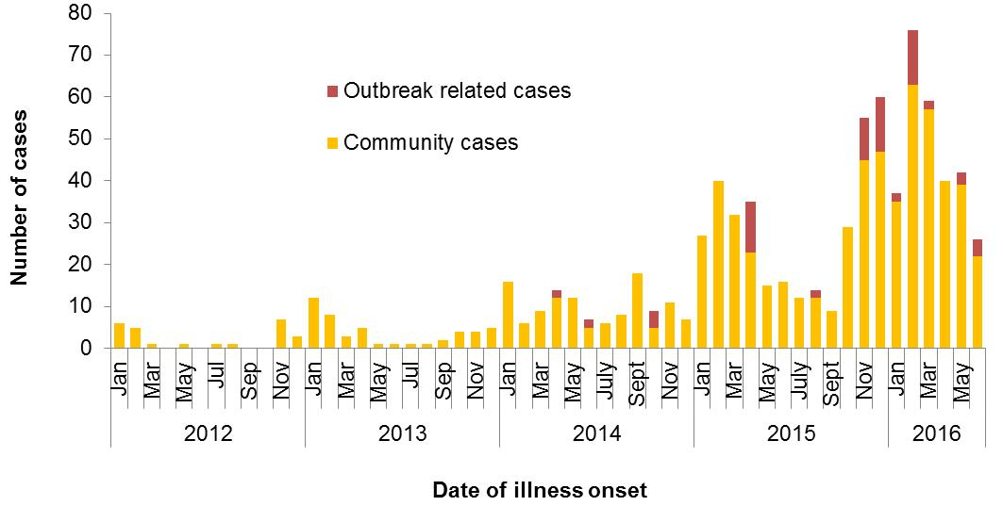

Figure 2 Notifications of *Salmonella* Typhimurium PFGE 0001 in WA, 2012 to June 2016

## *Salmonella* Typhimurium MLVA 04-14-00-00-463

Five cases notified with specimen dates in April 2016, compared to historical average of <1 case per month. Cases included two males and three females from metropolitan Perth (n=3) and rural areas (n=2), with a median age of 23 years (range 18-52 years). Three cases were interviewed, but no hypothesis for the cause of illness could be established.

## 4.3 *Salmonella* Typhimurium MLVA 03-12-13-08-523

Four cases notified with specimen dates in late March and early April 2016 and all resided in one rural public health region. Since MLVA typing began in 2015, only two other cases of this MLVA type have been notified. Cases included three males and one female case, with ages 1, 24, 33 and 63 years. Cases were interviewed but no hypothesis for the cause of illness could be established.

## 4.4 *Salmonella* Newport

An increase in *S.* Newport was identified, with eight cases reported in May. The historical 5-year average for the same period was one case. There were four female and four male cases with seven cases from metropolitan Perth and one case from a rural area. The median age was 32.5 years (range 1 to 62 years). Six cases reported acquiring their illness overseas, with five visiting Indonesia and one visiting Thailand.

# Non-foodborne disease outbreaks and outbreaks with an unknown mode of transmission

There were 17 outbreaks of enteric disease in this quarter that appeared to be non-foodborne (Table 6). Of these, 13 outbreaks were ascribed to person-to-person transmission and four outbreaks had an unknown mode of transmission.

Table 6 Outbreaks with non-foodborne transmission, 2nd Quarter 2016, WA



1 Deaths temporally associated with gastroenteritis, but contribution to death not specified

## Person-to-person outbreaks

In the 13 non-foodborne outbreaks that were suspected to be due to person-to-person transmission, seven (54%) outbreaks occurred in RCFs, four (31%) were in child care centres and two (15%) were in hospitals. The causative agent for five (38%) outbreaks was confirmed as norovirus. The remaining eight (62%) outbreaks were of unknown aetiology as specimens were either not collected (n=7) or were negative for common viral and bacterial pathogens (n=1).

A total of 203 people were affected in these 13 outbreaks, with six reported hospitalisations and two associated deaths. The number of person-to-person outbreaks in the 2Q16 was 43% lower than the second quarter 5-year mean (n=23).

## Outbreaks with unknown mode of transmission

There were four outbreaks in this quarter with an undetermined mode of transmission, with 28 people ill and one reported hospitalisation. Three of these outbreaks were in RCFs where the most common symptom reported was diarrhoea, and vomiting was reported infrequently, which is not typical of norovirus outbreaks in care settings. In two of the three outbreaks, stool specimens were tested but were negative for common bacterial and viral pathogens. Stool specimens were not collected during one outbreak. The fourth outbreak with unknown transmission was set at a rural caravan park (see summary below).

## 5.2.1 Rural caravan park, STEC (Outbreak code 088-2016-001)

There were two cases of shiga toxin-producing *E. coli* who had visited a rural caravan park during their incubation period. One case had stayed at the caravan park from 20/5/16 -22/5/2016 and had an onset of illness of 22/5/2016. The other case had been staying at the caravan park from early May onwards and had illness onset of 29/5/2016. Symptoms included diarrhoea (100%), bloody diarrhoea (100%), vomiting (50%) and fever (50%). One case was hospitalised and duration of diarrhoea was 4-10 days. Both cases did not know of anyone else ill and had no contact with farm animals and no other exposures in common. Bore water used at the caravan park did not meet the microbiological standards for potable water. One case drank the bore water and used the water for ablutions (washing hands, teeth, showering). The other case only used the water for ablutions. The toilets at the caravan park were unisex so it is possible that the case with later onset acquired their illness from contact with a contaminated ablution area. The mode of transmission was unknown.

# Site activities

During the second quarter of 2016, the following activities were conducted at the WA OzFoodNet site:

* Ongoing surveillance of foodborne disease in WA.
* Monitoring culture-independent nucleic acid amplification diagnostic testing in private laboratories and impact on notification rates.
* Investigation of three probable foodborne outbreaks.
* Investigation and monitoring of 13 person-to-person gastroenteritis outbreaks and four outbreaks with unknown mode of transmission.
* Ongoing investigation of a community-wide increase in *Salmonella* Typhimurium PFGE 0001 and investigation of three other clusters.
* Responded to national OzFoodNet enteric disease surveillance requests.
* Attended the national OzFoodNet face-to-face meeting and OzFoodNet Genomics Workshop in Melbourne in June.
* Presented findings of *Salmonella* Typhimurium PFGE type 0001 outbreak investigations at the biannual meeting in June with Department of Agriculture and Food and the Department of Health.
* Interviewing *Salmonella* Enteritidis cases regarding travel status and attempting to identify risk factors in locally acquired cases.
* Chair of the [Listeria Series of National Guidelines](http://www.health.gov.au/internet/main/publishing.nsf/Content/cdna-song-listeriosis.htm) which has been published.
* Membership of OzFoodNet working groups on:
  + Outbreak register
  + Foodborne disease tool kit
  + Egg-related outbreaks
  + Culture-independent testing
* Participation in monthly national OzFoodNet teleconferences.

# References

1. Hall G, Kirk MD, Becker N, Gregory JE, Unicomb L, Millard G, et al. Estimating foodborne gastroenteritis, Australia. Emerg Infect Dis 2005;11(8):1257-1264.
2. OzFoodNet Working Group. A health network to enhance the surveillance of foodborne diseases in Australia. Department of Health and Ageing 2013. www.ozfoodnet.gov.au/internet/ozfoodnet/publishing.nsf/Content/Home-1 [14/03/2012].

This document can be made available in alternative formats on request for a person with a disability.

© Department of Health 2016