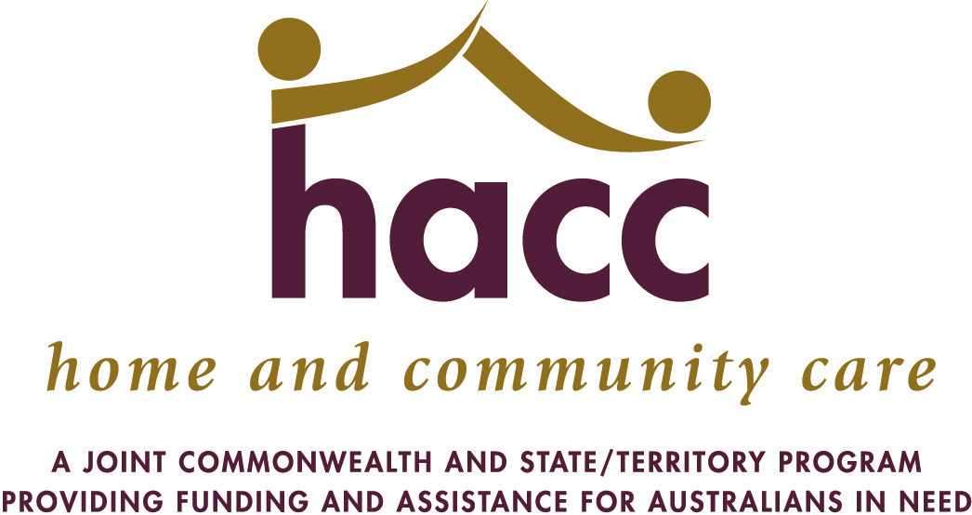
 | HOME and COMMUNITY CARE
 | 2015/16 GROWTH FUNDING APPROVALS
 | Organisation |  | Recurrent
 |  |  | $ (FYE)
 | ALBANY COMMUNITY CARE CENTRE (WA) INC |  | $226,891
 | ALZHEIMER'S AUSTRALIA WA LTD |  | $587,350
 | ANCHOR HOME HELP INC |  | $176,729
 | ASTLEY CARE INC |  | $154,453
 | AVIVO: LIVE LIFE |  | $74,145
 | BASSENDEAN TOWN OF |  | $70,286
 | BAYSWATER EXTENDED COMMUNITY HELP ORGANISATION INC |  | $69,397
 | BESS HOME AND COMMUNITY CARE INC |  | $89,406
 | BETHANIE GROUP INC |  | $51,533
 | BRIGHTWATER CARE GROUP INC |  | $213,481
 | CANNING CITY OF |  | $204,408
 | CAPECARE |  | $1,280
 | CARE OPTIONS INC |  | $175,493
 | CHUNG WAH ASSOC INC |  | $168,788
 | COCKBURN CITY OF |  | $231,133
 | COMMUNITY FIRST INTERNATIONAL LTD |  | $103,978
 | COMMUNITY HOME CARE BUNBURY |  | $112,341
 | DADAA LIMITED |  | $27,077
 | HARVEY HEALTH AND COMMUNITY SERVICES GROUP |  | $171,813
 | IDENTITY WA |  | $16,779
 | INDEPENDENT LIVING CENTRE OF WA INC |  | $471,567
 | KALAMUNDA SHIRE OF |  | $64,063
 | MANJIMUP SHIRE OF |  | $124,917
 | MELVILLE CARES |  | $194,728
 | MERCY COMMUNITY SERVICES INC |  | $275,508
 | MIDWEST HEALTH REGION |  | $71,317
 | NGANGGANAWILI HEALTH SERVICE |  | $51,365
 | PEEL COMMUNITY CARE INC |  | $225,859
 | PEOPLE WHO CARE INC. |  | $340,638
 | RISE - NETWORK INC |  | $239,515
 | SILVER CHAIN GROUP LIMITED |  | $1,550,915
 | SOUTH WEST HEALTH REGION |  | $33,302
 | SOUTHERN CROSS CARE WA INC |  | $30,445
 | Organisation |  | Recurrent
 |  |  | $ (FYE)
 | SOUTHERN DISTRICTS SUPPORT ASSOC. |  | $192,136
 | ST IVES CARE PTY LTD |  | $263,826
 | SWAN CITY OF |  | $160,605
 | TAPSS COMMUNITY SERVICES |  | $277,677
 | TECHNOLOGY ASSISTING DISABILITY WA INC |  | $300,434
 | UMBRELLA MULTICULTURAL COMM. CARE SVCS INC |  | $135,213
 | UNITING CHURCH HOMES |  | $197,732
 | VOLUNTEER HOME SUPPORT |  | $233,619
 | VOLUNTEER TASK FORCE INC |  | $298,574
 | WANNEROO CITY OF |  | $118,819
 | * Note Current as at 30 June 2016 |  | $8,779,535

