

This report describes enteric disease surveillance and investigations carried out during the first quarter of 2020 (1Q20) by OzFoodNet WA in conjunction with other Western Australian Department of Health agencies and local governments.

Some of the increase in notifications is likely to be due to the introduction of polymerase chain reaction (PCR) testing of faecal specimens which has greater sensitivity than culture techniques.

**OzFoodNet Enteric Disease Surveillance Report 1st Quarter 2020**

**Enhancing foodborne disease surveillance across Australia**

**Appendix 1** Enteric diseases by public health region:

[https://ww2.health.wa.gov.au/-/media/Corp/Documents/Health for/Infectious disease/OZfoodnet/Word/WA-OzFoodnet-appendix1-2020-Q1.docx](https://ww2.health.wa.gov.au/-/media/Corp/Documents/Health%20for/Infectious%20disease/OZfoodnet/Word/WA-OzFoodnet-appendix1-2020-Q1.docx)

**Most common enteric disease notifications in Quarter 1 2020**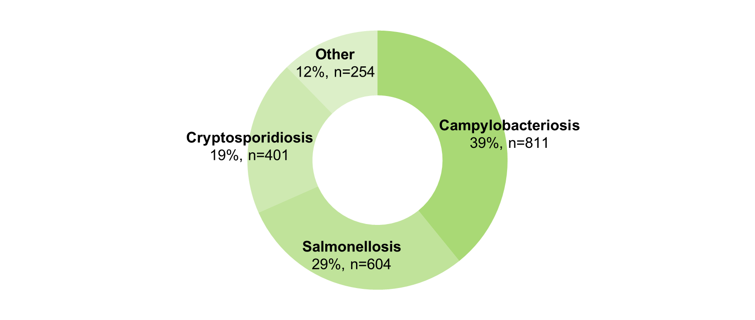

*Percentage change in the number of notifications in the current quarter compared to the historical 5-year mean for the same quarter. Positive values indicate an increase when compared to the historical 5-year mean of the same quarter. Negative values indicate a decrease when compared to the historical 5-year mean of the same quarter. Percentage change should be interpreted with caution when the number of cases is small.

**Change in enteric disease notifications (%)\***

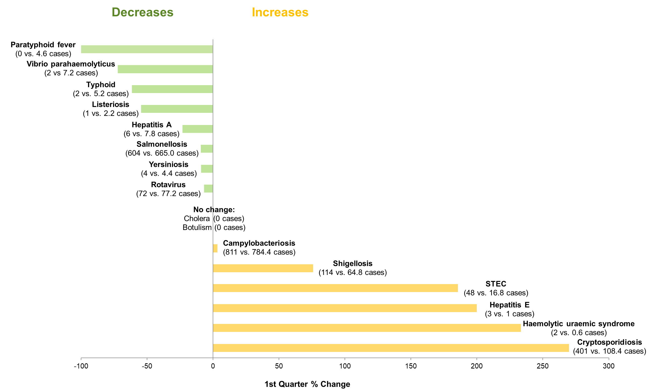

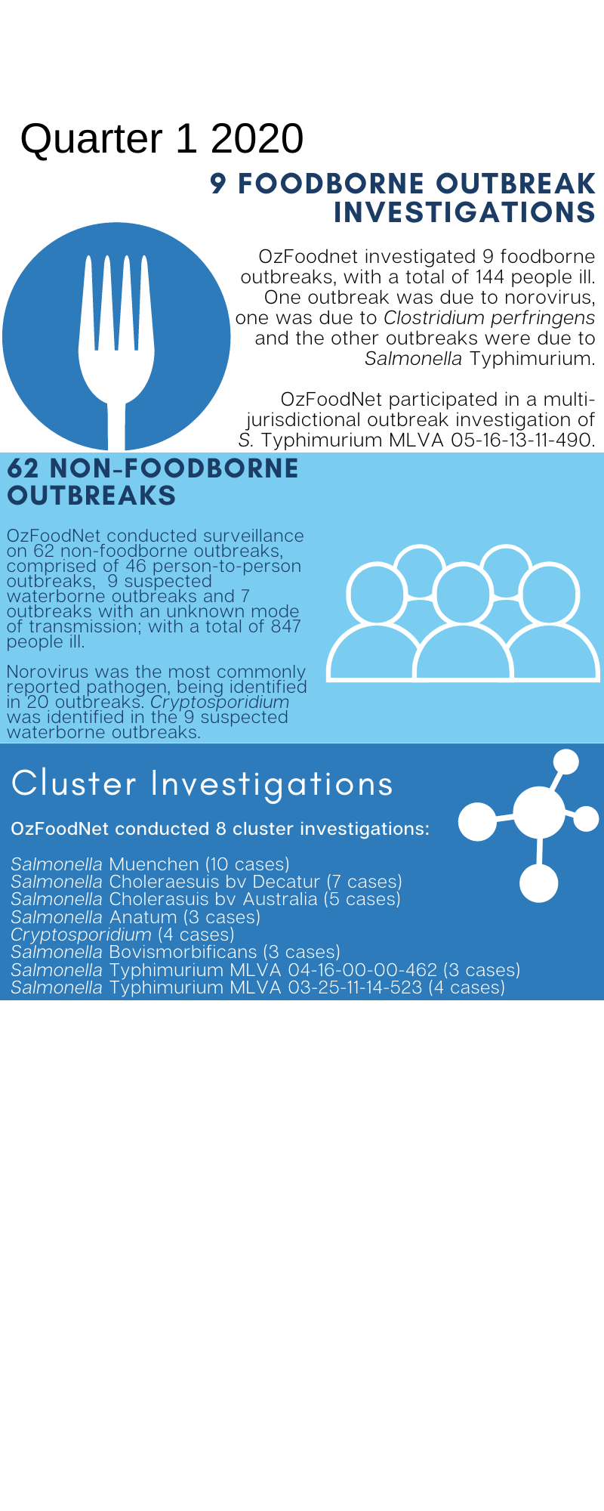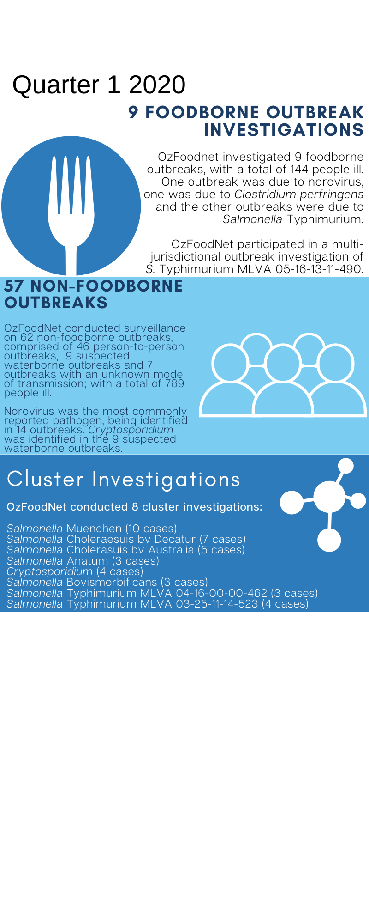**Outbreaks in Quarter 1 2020**

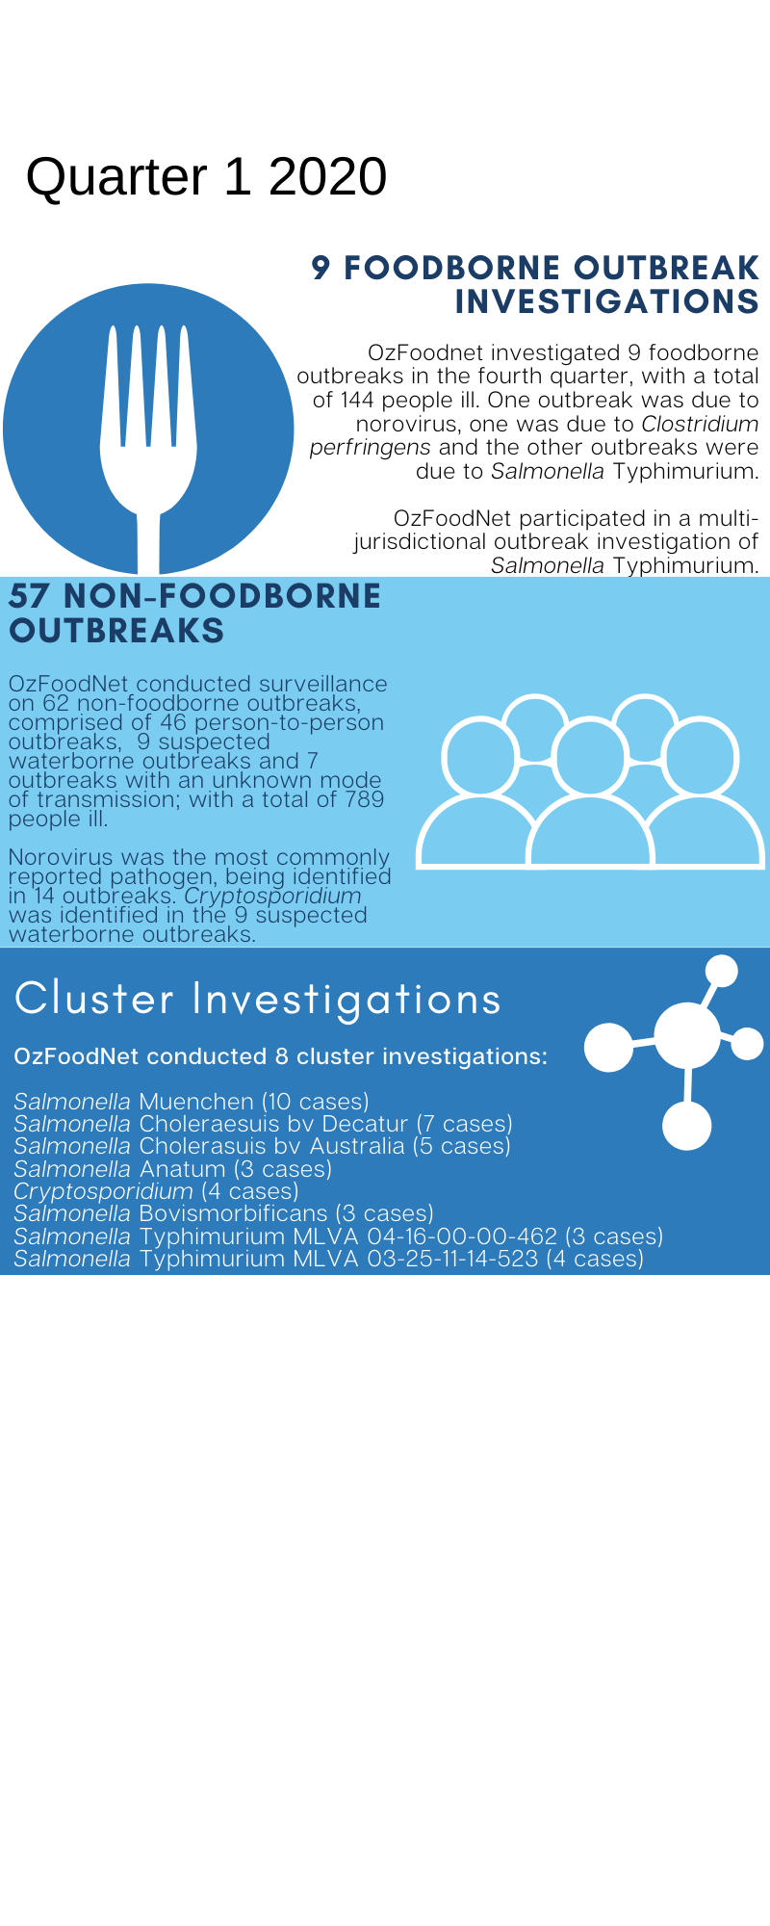

**Appendix 2** Details of foodborne outbreaks investigated in Quarter 1, 2020:

[https://ww2.health.wa.gov.au/-/media/Corp/Documents/Health for/Infectious disease/OZfoodnet/Word/WA-OzFoodnet-appendix2-2020-Q1.docx](https://ww2.health.wa.gov.au/-/media/Corp/Documents/Health%20for/Infectious%20disease/OZfoodnet/Word/WA-OzFoodnet-appendix2-2020-Q1.docx)

**Key trends from Quarter 1 2020**

***Salmonella* Typhimurium (STM) MLVA 03-17-09-12-523**

STM MLVA 03-17-09-12-523 has been under investigation since the type emerged in September 2016. From September 2016 to March 2020 there were 1582 cases notified, including 108 cases in 1Q20. This MLVA type was the single most common MLVA type notified in 1Q20, constituting 34% of STM notifications for the quarter. Of the 108 cases, 22 (20%) were part of three point source outbreaks identified in 1Q20. A beef lasagne with undercooked pasta sheets containing raw eggs was implicated in one outbreak; the vehicle was unknown in the other two 1Q20 outbreaks of this MLVA type which were at aged care facilities. Of the remaining 86 cases, most (91%) resided in the Perth metropolitan area. Hospitalisation data were confirmed for 73 community cases; 23% were hospitalised.



Figure 1: Notifications of *Salmonella* Typhimurium MLVA 03-17-09-12-523 in WA, 2016 to March 2020

**Cryptosporidiosis**

A large cryptosporidiosis outbreak in the Perth metro area was investigated in the 1Q20. A total 376 cases were reported with onsets between 1st December 2019 and 31st March 2020. Under-fives were the most affected age group making up 33% of total cases. Twenty-four cases were hospitalised. Interviews were completed for 158 cases. Aquatic facilities were identified as the major exposure with multiple point source outbreaks detected.

Of cases interviewed, 58 cases were linked to nine different aquatic facilities. In response a media statement was released urging people who have had diarrhoea not to enter any aquatic facility until at least two weeks after they have fully recovered. Local Government Environmental Health Officers were informed of point source outbreaks at aquatic facilities and followed up to review their records, ensure correct operational procedures were in place and in some cases recommend hyperchlorination.

Due to COVID-19, strict social distancing measures were implemented throughout March which included the closure of all aquatic facilities on the 26th March. There was a marked reduction in cases in March, effectively ending the outbreak with levels returning close to baseline by the end of April.



**Figure 2: *Cryptosporidium* cases by week of optimal onset, WA, December 2019 – March 2020**

**Haemolytic uraemic syndrome (HUS)**

Two HUS cases were notified in 1Q20. One case was PCR positive for *Shigella*, epidemiologically linked to a case who was positive for *Shigella* *flexneri* 2B. The second case was culture positive for STEC (serotype O165:H25).

**Shiga toxin producing *E. coli* (STEC)**

Fifteen of the 48 notifications were culture positive, the most common serotypes were O130:H11 (n=2) and O165:H25 (n=2). No point source outbreaks were identified in 1Q20. Some of the increase is likely due to PCR testing of all faecal specimens by one private laboratory since the fourth quarter of 2018.