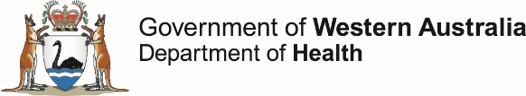

This report describes enteric disease surveillance and investigations carried out during the fourth quarter of 2020 (4Q20) by OzFoodNet WA in conjunction with other Western Australian Department of Health agencies and local governments.

The decrease in notifications in 4Q20 is likely to be due the ongoing travel restrictions due to COVID-19 and possible improvements in hand hygiene in the general community.

**OzFoodNet Enteric Disease Surveillance Report 4th Quarter 2020**

**Enhancing foodborne disease surveillance across Australia**

**Most common enteric disease notifications in Quarter 4 2020**



**Change in enteric disease notifications (%)\***



**Appendix 1** Enteric diseases by public health region:

<https://ww2.health.wa.gov.au/~/media/Corp/Documents/Health-for/Infectious-disease/OZfoodnet/Word/WA-OzFoodnet-appendix1-2020-Q4.docx>

*Percentage change in the number of notifications in the current quarter compared to the historical 5-year mean for the same quarter. Positive values indicate an increase when compared to the historical 5-year mean of the same quarter. Negative values indicate a decrease when compared to the historical 5-year mean of the same quarter. Percentage change should be interpreted with caution when the number of cases is small.

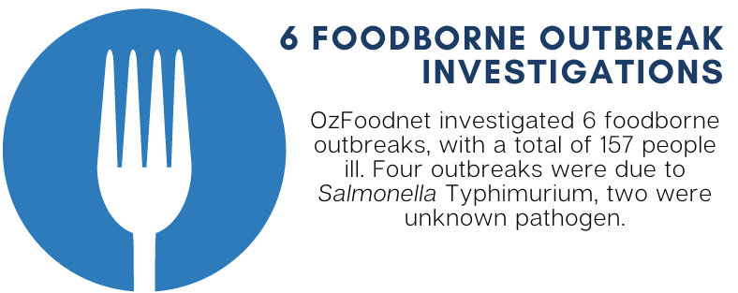 **Outbreaks in Quarter 4 2020**

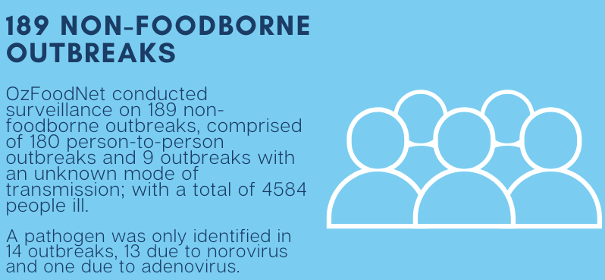

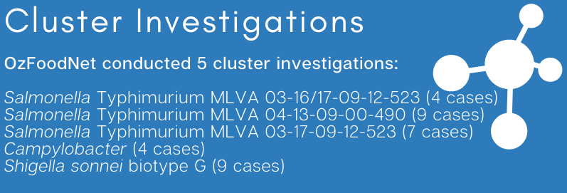

**Appendix 2** Details of foodborne outbreaks investigated in Quarter 4, 2020:

<https://ww2.health.wa.gov.au/~/media/Corp/Documents/Health-for/Infectious-disease/OZfoodnet/Word/WA-OzFoodnet-appendix2-2020-Q4.docx>

**Key trends from Quarter 4 2020**

***Salmonella* Typhimurium (STM) MLVA 03-17-09-12-523**

STM MLVA 03-17-09-12-523 has been under investigation since the type emerged in September 2016. From September 2016 to December 2020 there were 1868 cases notified, including 57cases in 4Q20.

This MLVA type was the single most common MLVA type notified in 4Q20, constituting 24% of STM notifications for the quarter.

Of the 57 cases, 3 (5%) were part of a point source outbreak (outbreak code 042-2020-018). There was also an additional outbreak (outbreak code 042-2020-017) of STM MLVA 03-17-09-12-523 investigated in the 4Q20, but the dates of onset were in late September.

Tiramisu containing raw eggs was implicated in both outbreaks. Of the remaining 54 cases, most (91%) resided in the Perth metropolitan area. Hospitalisation data were confirmed for 46 community cases; 17% were hospitalised.



Figure: Notifications of *Salmonella* Typhimurium MLVA 03-17-09-12-523 in WA, 2016 to December 2020

**Non-Foodborne outbreaks**

In the 4Q20, there were 189 non-foodborne outbreaks compared to the previous five-year average of 52 outbreaks. The 189 outbreaks included 180 probable person-to-person outbreaks and nine outbreaks were the transmission was unknown. Most (80%) of these outbreaks were in child care facilities. Only a small proportion (7%) of facilities had stool specimen tested and when these specimens were positive for a pathogen, the most common (5/6, 83%) result was norovirus. The WA public health reference laboratory-PathWest reported that a “new” norovirus strain was circulating in the WA community at this time.

***Listeria***

Two *Listeria* cases were notified in 4Q20, both non-perinatal cases including a 76-year-old male who was diagnosed with meningitis and co-morbidities included type 2 diabetes and skin cancer. Partial food history obtained and no high-risk foods identified. The other case was a 72-year-old male who was diagnosed with septicaemia and whose death was linked to their *Listeria* illness. Co-morbidities included hypertension, peptic ulcer and heart disease. Food eaten during incubation period included a number of high-risk foods. *Listeria* strains of cases were typed and considered unique.

**Shiga toxin producing *E. coli* (STEC)**

Six of the 17 STEC notifications were culture positive, the most common serotypes were O128:H2 (n=2). No point-source outbreaks were identified in 4Q20. Some of the increase is likely due to PCR testing of all faecal specimens by one private laboratory since the fourth quarter of 2018.

**Multi-drug resistant *Shigella***

All nine notifications of *Shigella sonnei* Biotype G reported in 4Q20 were alerted as multi-drug resistant. All cases were men in the Perth metro area thought to have acquired their infection through male to male sexual contact.

**Typhoid**

There were four cases of typhoid reported in the 4Q20.

* Two of these cases were a mother/child pair. The child was a 2 year old male who was tested as they had diarrhoea and fever, with onset 13/11/2020 and had not travelled overseas prior to illness. The 34 year old positive mother was asymptomatic, last travelled to India in November 2019, with relatives from India visiting from Feb-August 2020. It is probable that child acquired their illness from the mother.
* The second pair of cases were a 33 year old female who was tested as she was symptomatic with onset 07/11/2021 and last travel overseas in January 2019. This case was a house-hold contact of her asymptomatic 75 year old mother-in-law, who arrived from India on 16/12/2019. It is probable that the 33 year old acquired their illness from the mother-in-law.
* Whole genome sequences was performed on all four strains and the first pair of cases were genetically distinct from the second pair of cases.