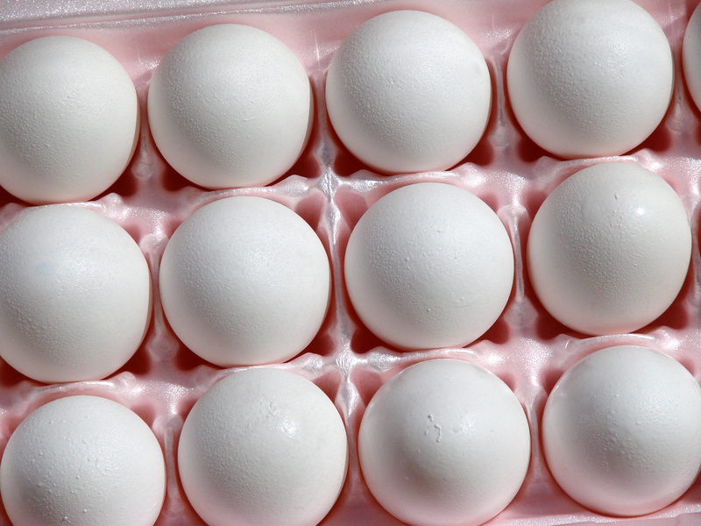

Guideline Food Safety Management Statement for Egg Producers: Production of eggs only, no grading

NOTE: This Guideline food safety management statement is intended to assist egg businesses that grows eggs only complete a food safety management statement. It is not intended for businesses that grade eggs.



Important notes for egg businesses in using this document:

Completion of a food safety management statement is a legal requirement for all commercial egg producers and processors under the Primary Production and Production Standard for Eggs and Egg Products (the Egg Standard).

- This Guideline food safety management statement is an aid to assist businesses that produce eggs but do not undertake any further activity (e.g. grading of eggs, processing of egg pulp or egg product) complete a food safety management statement.

- This Guideline in itself is not a legal document.

- The criterion described in this Guideline represents an agreed minimum against which food regulators will assess a business’s food safety management statement

- Businesses are referred to the reference materials listed at the end of this Guideline (Appendix 1) for advice on prescriptive details and methodologies that may be used in developing a food safety management statement.

- Businesses should construct their food safety management statements to reflect the size and complexity of their own operations - no two businesses will have identical food safety management statements.

- Businesses are also suggested to contact their state/territory food regulator for further detail concerning compliance requirements before submitting their food safety management statement for assessment.

Food Safety Management Statement - Business Details

Name of Business:_____________________________________________ _____________________________________________________________
Address of Business:___________________________________________ _____________________________________________________________
Phone No:_____________________email:__________________________
Description of activities undertaken at this business:________________ _____________________________________________________________
_____________________________________________________________
_____________________________________________________________
_____________________________________________________________
_____________________________________________________________
_____________________________________________________________
_____________________________________________________________
Approximately number of laying hens:____________________________
Approximately number of eggs produced per week:_________________
Name of Proprietor or designated representative:___________________
_____________________________________________________________
Number of businesses supplied to:_______________________________
Name of food regulator:_________________________________________

SECTION 1: MANAGEMENT RESPONSIBILITY

1.1 Scope of the Food Safety Management Statement (Activities undertaken at the business)

Describe in your own words, the activities of your business. For example, do you sell off farm? Do you sell directly at farmers markets? How do you grade your eggs? How do you collect and store? Note: some of these questions may be duplicated below.
________________________________________________________________________________________________________________________________________________________________________________________________________________________________________________________________________________________________________
__________________________________________________________________________

SECTION 2: EGG PRODUCTION OPERATIONS

2.1 Egg Collection

Describe how your business manages cracked eggs during egg collection? How frequently do you collect eggs? How do you separate cracked and dirty eggs during collection (i.e. describe your egg collection process).
________________________________________________________________________________________________________________________________________________________________________________________________________________________________________________________________________________________________________
__________________________________________________________________________

What do you do with cracked eggs? Do you supply them to a business that processes egg pulp and egg product? If so, describe how you collect, store and transport cracked eggs intended for sale and supply to a business that processes egg pulp and egg product?
________________________________________________________________________________________________________________________________________________________________________________________________________________________________________________________________________________________________________
__________________________________________________________________________

Describe what evidence your business maintains to verify your above statements? (e.g. disposal logs).
________________________________________________________________________________________________________________________________________________________________________________________________________________________________________________________________________________________________________
__________________________________________________________________________
__________________________________________________________________________

2.2 Egg Storage

Describe how your business stores eggs. How do you keep your storage facilities clean? Do you apply time / temperature controls during storage?
________________________________________________________________________________________________________________________________________________________________________________________________________________________________________________________________________________________________________
__________________________________________________________________________

Describe what evidence your business maintains to verify your above statement? (i.e. describe your egg storage conditions)
________________________________________________________________________________________________________________________________________________________________________________________________________________________________________________________________________________________________________
__________________________________________________________________________

2.3 Egg Transport

Describe how your business transports eggs. Are cracked eggs transported with whole eggs?
________________________________________________________________________________________________________________________________________________________________________________________________________________________________________________________________________________________________________
__________________________________________________________________________
__________________________________________________________________________

Describe what evidence your business maintains to verify your above statement? (e.g. disposal logs, distribution logs).
________________________________________________________________________________________________________________________________________________________________________________________________________________________________________________________________________________________________________
__________________________________________________________________________

SECTION 3: INPUTS

3.1 Stockfeed

Describe how your business obtains stockfeed for its laying hens, e.g.; what vendor declarations do you obtain from the supplier or do you prepare your own stockfeed?
________________________________________________________________________________________________________________________________________________________________________________________________________________________________________________________________________________________________________
__________________________________________________________________________
__________________________________________________________________________

Describe what evidence your business maintains to verify your above statement? (e.g. how long does your business keep vendor declarations?)
________________________________________________________________________________________________________________________________________________________________________________________________________________________________________________________________________________________________________
__________________________________________________________________________

3.2 Pesticides and veterinary medicines

Describe what evidence your business maintains to verify that veterinary chemicals administered to laying hens do not adversely affect egg safety? (e.g. hen treatment log specifying withholding periods for treated hens)
________________________________________________________________________________________________________________________________________________________________________________________________________________________________________________________________________________________________________
__________________________________________________________________________

3.3 Water supply

Describe the water source your business uses to supply laying hens with drinking water and what water supply is used for cleaning?
________________________________________________________________________________________________________________________________________________________________________________________________________________________________________________________________________________________________________
__________________________________________________________________________
__________________________________________________________________________

Describe what evidence your business maintains to verify your above statement? (e.g. certificate of pathogen status of water supply)
________________________________________________________________________________________________________________________________________________________________________________________________________________________________________________________________________________________________________
__________________________________________________________________________

3.4 Sourced birds

Describe what evidence your business will maintain to verify that chicks purchased for laying hen stock do not adversely affect egg safety? (e.g. do you need a declaration from the supplier that the chicks are free from Salmonella Enteritidis?)
________________________________________________________________________________________________________________________________________________________________________________________________________________________________________________________________________________________________________
__________________________________________________________________________

3.5 Litter and nesting box material

Describe what evidence your business maintains to verify that your nesting box material is free from contaminants? (e.g. pathogen declaration from supplier)
________________________________________________________________________________________________________________________________________________________________________________________________________________________________________________________________________________________________________
__________________________________________________________________________

SECTION 4: WASTE DISPOSAL

Describe how your business intends to manage waste generated during egg production. This includes the disposal of cracked and dirty eggs and unpasteurised egg pulp. For example, are you sending egg pulp for pasteurisation, or are you going to dispose of it? What do you do about dead birds? What do you do about other waste material?
________________________________________________________________________________________________________________________________________________________________________________________________________________________________________________________________________________________________________
__________________________________________________________________________

Describe what evidence your business maintains to verify your above statement? (e.g. distribution logs, disposal logs)
________________________________________________________________________________________________________________________________________________________________________________________________________________________________________________________________________________________________________
__________________________________________________________________________
_________________________________________________________________________

SECTION 5: HEALTH AND HYGIENE

5.1 Egg handler health and hygiene

Describe what personal hygiene practices your business intends to implement to manage potential contaminants to egg and unpasteurised egg pulp safety being introduced by persons involved in egg handling activities?
________________________________________________________________________________________________________________________________________________________________________________________________________________________________________________________________________________________________________
__________________________________________________________________________

Describe the procedures your business will implement to prevent illnesses or other health associated ailments from adversely affecting egg safety?
________________________________________________________________________________________________________________________________________________________________________________________________________________________________________________________________________________________________________
__________________________________________________________________________

Describe what clothing requirements/dress standards your business will introduce to prevent staff, from their clothing or personal effects, introducing contaminants to eggs or unpasteurised egg pulp that may adversely affecting egg safety?
______________________________________________________________________________________________________________________________________________________________________________________________________________________________________________________________________________________________________
__________________________________________________________________________

SECTION 6: SKILLS AND KNOWLEDGE

Describe what training system is employed by your business to ensure that staff involved in egg or unpasteurised egg pulp handling activities are competently trained in food safety and hygiene practices?
________________________________________________________________________________________________________________________________________________________________________________________________________________________________________________________________________________________________________
__________________________________________________________________________

Describe what evidence (records) your business maintains to verify your above statements?
________________________________________________________________________________________________________________________________________________________________________________________________________________________________________________________________________________________________________
__________________________________________________________________________
__________________________________________________________________________

SECTION 7: DESIGN, CONSTRUCTION AND MAINTENANCE OF PREMISES, EQUIPMENT AND TRANSPORTATION VEHICLES

7.1 Premises, equipment and transportation vehicles

Describe what practices are employed by your business to ensure that all premises, equipment and transportation vehicles used in, or associated with egg production operations (includes unpasteurised egg pulp - if appropriate) are constructed and maintained in such a way as to minimise contamination to eggs? (e.g. cleaning and maintenance programs)
________________________________________________________________________________________________________________________________________________________________________________________________________________________________________________________________________________________________________
__________________________________________________________________________

Describe what evidence (records) your business maintains to verify your above statement? (e.g. maintenance and cleaning registers)
________________________________________________________________________________________________________________________________________________________________________________________________________________________________________________________________________________________________________
__________________________________________________________________________

7.2 Pest Control

Describe what pest control measures will be employed by the business to prevent the entry of wild animals and birds, rodents, and domestic animals into egg and egg pulp collection, storage and transportation areas? (e.g. pest control program)
________________________________________________________________________________________________________________________________________________________________________________________________________________________________________________________________________________________________________
__________________________________________________________________________

Describe what evidence your business will maintain to verify that its pest control measures are kept up to date? (e.g. treatment log for pest control measures applied)
________________________________________________________________________________________________________________________________________________________________________________________________________________________________________________________________________________________________________
__________________________________________________________________________

SECTION 8: BIRD HEALTH

Describe how your business will manage issues concerning bird health (e.g. active surveillance of flock, removal of dead birds from flock). What veterinary medicines have been administered to hens? How do you identify treated hens? How do you ensure that withholding periods associated with veterinary medicines are complied with? _______________________________________________________________________________________________________________________________________________________________________________________________________________________________________________________________________________________________________
__________________________________________________________________________

Describe what evidence your business will maintain to verify the above requirement? (e.g. hen treatment log with withholding periods marked) ________________________________________________________________________________________________________________________________________________________________________________________________________________________________________________________________________________________________________
__________________________________________________________________________

SECTION 9: SALE AND SUPPLY

Form 1: Eggs Sales Record (Appendix 2) is a sample distribution log that includes:
- name and address of the person or business to whom the eggs are sold,
- the date on which the eggs are sold,
- the lot identification numbers of the eggs (i.e. date eggs produced), and
- the quantity of eggs sold.

Describe what evidence your business will maintain to verify the sale and supply of eggs for grading?
________________________________________________________________________________________________________________________________________________________________________________________________________________________________________________________________________________________________________
__________________________________________________________________________

Describe what evidence your business will maintain to verify the sale and supply of unpasteurised egg pulp to a business that processes egg pulp and egg product?
________________________________________________________________________________________________________________________________________________________________________________________________________________________________________________________________________________________________________
__________________________________________________________________________

APPENDIX 1: REFERENCES

1. FSANZ (2011), Primary Production and Processing Standard for Eggs and Egg Product
http://www.foodstandards.gov.au/_srcfiles/Gazette%20Notice%20Amendment%20No%20123%20WEB%20VERSION.pdf
2. Australian Egg Corporation Limited (2008), Code of Practice For Shell Egg, Production, Grading, packing and Distribution
(http://www.aecl.org/system/attachments/279/original/Shell_Egg_Code_Of_Practice_January_2009_-_3.pdf?1265605129)
3. Codex (2007), Code of Hygienic Practice for Eggs and Egg Products
http://www.fao.org/docrep/012/i1111e/i1111e01.pdf

Appendix 2: Form 1 Distribution logs

Date Sold | Name | Address | Date Produced | Quantity Sold

