International Day of People with Disability 2025

Regional realities: Health and disability in country WA
Wednesday 3 December 2025 at 11.30am to 2.00pm at Grace Vaughan House
Delivered by WA Country Health Service in partnership with Disability Health Network
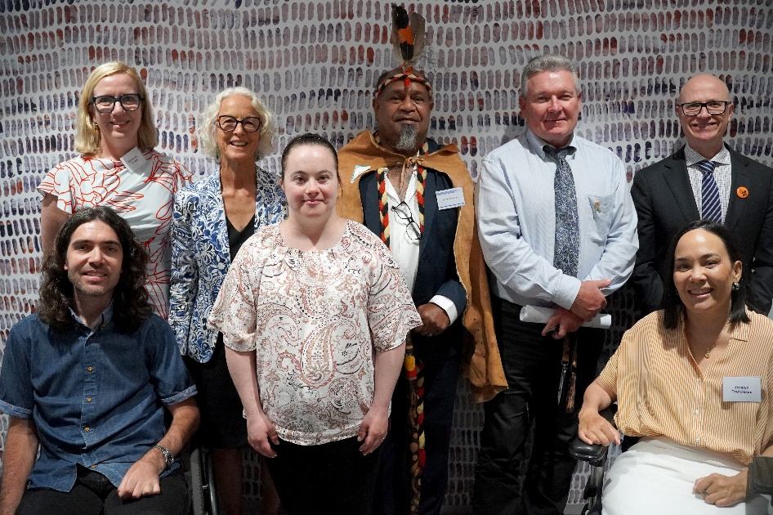
Figure 1: Back row left to right - Stephanie Coates, Melissa Vernon, Uncle Vaughn McGuire, Jeff Moffet, Mike Rowe. Front row left to right - Jaimen Hudson, Naomi Lake, and Jocelyn Franciscus.
Jaimen Hudson, Naomi Lake, and Sandy Dann shared their stories of living with disability in regional WA.
They spoke to us of the vital role our health staff play, the moments they share with their patients, and the impact they can have in people’s lives.
Each speaker shared their insights about the importance of health staff working with compassion, understanding a person’s disability, and seeing patients as individuals.

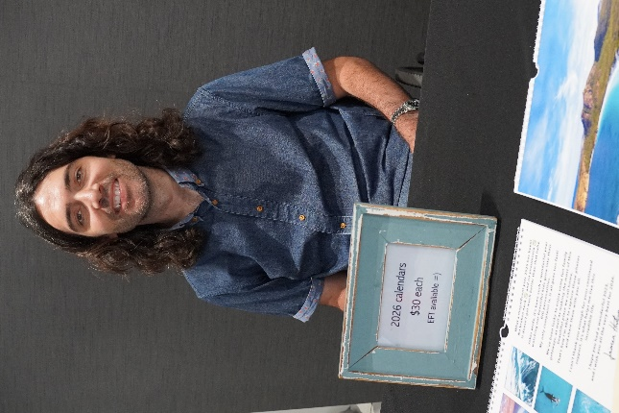
“I remember when I woke up … I moved my arms and the nurse that was there, I hugged her... It was a beautiful moment that I shared with a stranger. And the reason I wanted to share that with you is because they're the moments that nurses are there for.”
– Jaimen Hudson speaking about his post-surgery experience after his second spinal fracture
“The reality is I can't fly on my own, I need to have someone come with me, which usually ends up being my wife… I've got to bring two kids, and I've got to pay for their flights and then accommodation and everything just starts to add up a lot… So since telehealth has been in, it's been a game changer”
– Jaimen Hudson

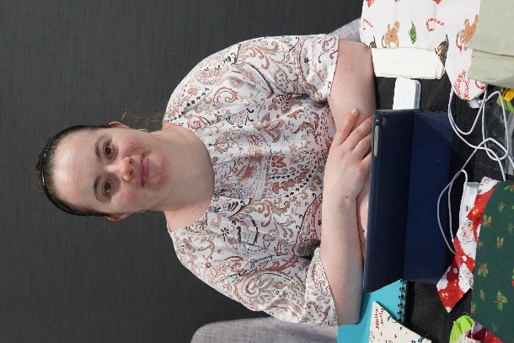
“I have a really good doctor. He always greets me with a smile… He gives me time to think and respond. He checks that I understand what he's saying… He treats with me with respect. But most of all, he talks to me, not my mother.”

“It is important for you as a health professional to have a better understanding of people with intellectual disability. We are individuals and need to be accepted, respected and treated as such when we take your practice.”
– Naomi Lake

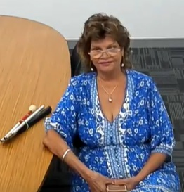

“A cane, whether it's being used for a visually impaired person or somebody that can't walk properly, is a personalised piece of equipment. It becomes a part of somebody”
– Sandy Dann speaking about her cane (Mr Cane) being an extension of herself

138 people attended the event in-person and online from across WA Health, community service providers, carers, and consumers. Every year, the Disability Health Network partners with a Health Service Provider to celebrate international Day of People with Disability.

