2025 Staff with Disability and Allies’ Network (SDAN) Conference

Executive Summary

Design to thrive: Attracting and retaining WA Health staff with disability

Classification: Official

Contents

Background 1

Call to action 2

Event overview 4

Key action areas, challenges, and opportunities 6

## Background

The purpose of this document is to provide a summary of key outputs from the 2025 Staff with Disability and Allies’ Network (SDAN) conference to promote collective action to better support staff with disability across WA Health.

A full report of the event is available on the Disability Health Network website: <https://www.health.wa.gov.au/Articles/A_E/Disability-Health-Network>

### The case for enhanced support for staff with disability

The WA Public Sector has an aspirational employment target of 5% for people with disability.[1] As of March 2025, people with disability made up just 1.7% of the overall public sector workforce.[2]

Inclusive workplaces:[3]

* Improve mental and emotional health of all staff.
* Promote staff retention.
* Increase productivity, innovation, collaboration, and customer service.
* Reduce staff experiences of discrimination and harassment.

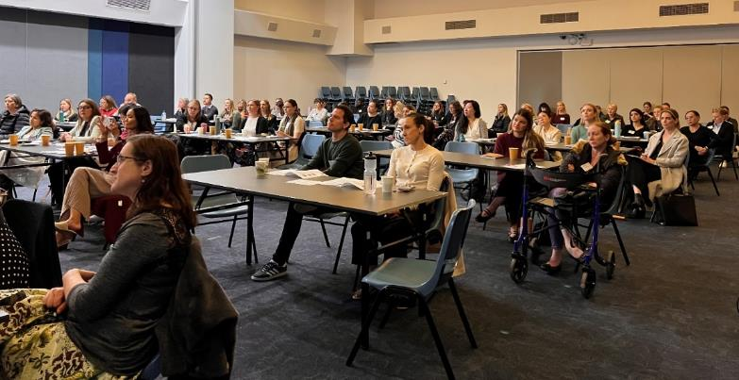

**Figure 1:** Conference attendees listening to the panel discussion on hidden disability.

## Call to action

The follow priority areas have been pulled from the information themed from the Innovation Lab (see Key action areas, challenges, and opportunities). All priorities are intended to be designed, developed, and delivered in collaboration with relevant teams across WA Health and staff with disability.

“We can have sometimes inaccessible places and things, but if there’s a willingness to troubleshoot and just to give it a try, I think the attitude matters more than the environment sometimes.”

– Dr Dinesh Palipana

|  |  |  |
| --- | --- | --- |
| **Priority** | **Enablers** | **Timeframe** |
| 1. Executives from each Health Service Provider (HSP), Heath Support Service (HSS) and Department of Health (the Department) commit to supporting disability inclusion by actively engaging with SDAN and creating clear plans to reach the 5% employment target for people with disability. | * Commitment from each HSP Chief Executive and the Director General. * WA Health Disability Access and Inclusion Plan, with local action plans (see priority 2). | 12-18 months |
| 1. Develop a statewide co-designed Disability Access and Inclusion Plan (DAIP) with local action plans from all HSPs. | * Agreement from the Health Executive Committee. * Establish a statewide working group. | 12 months |
| 1. Implement the [Hidden Disability Sunflower initiative](https://hdsunflower.com/au/) across all WA Health entities. | * Agreement from the Health Executive Committee. | <12 months |
| 1. Create and implement a WA Health standardised suite of resources on inclusive recruitment and onboarding for use across WA Health, working with HSS to integrate into existing processes where possible. | * Commitment from each HSP Chief Executive and the Director General. | <12 months |
| 1. Include Section 66R of the *Equal Opportunity Act* (preferential appointment of successful candidates with disability) in all WA Health job advertisements. | * Commitment from each HSP Chief Executive and the Director General. * Fulfilment of priority 4. | 12 months |
| 1. Standardise the use of co-designed training on diversity and inclusion as a component of induction and onboarding for people in managerial or leadership roles. | * Commitment from each HSP Chief Executive and the Director General. | 18-24 months |
| 1. Introduce key performance indicators for leaders on:    * Safety (particularly psychosocial safety).    * Completed training on diversity, inclusion, and intersectionality.    * Implementation of strategies to support diversity, inclusion, and psychosocial safety. | * Commitment from each HSP Chief Executive and the Director General. | 18-24 months |
| 1. Create an inclusive process for supporting staff with disability to request adjustments in the workplace that is not part of the Fitness for Work process. | * Commitment from each HSP Chief Executive and the Director General | 18-24 months |

## Event overview

The 2025 Staff with Disability and Allies’ Network conference was held on 17 June at the Bendat Parent and Community Centre. It was the second conference of its kind.

* Theme: Design to thrive: Attracting and retaining WA Health staff with disability.
* Purpose: to provide an opportunity for all WA Health staff to listen to the lived experience of people with disability, learn from their stories, and discuss ways to improve the culture and inclusion practices across WA Health for staff with disability.
* Total conference attendees: 131 (75 in-person) and (56 online).
* Attendee mix: attendees represented a wide variety of identities and roles, including staff with disability, family members and friends of people with disability, health professionals, policy and administrative staff, and managers and executives.

A video of the keynote speech and panel discussion is available on the WA Health YouTube channel: <https://www.youtube.com/watch?v=tTS5bnT_W_s>

### Conference structure

An event program, and speaker profiles can be found here: <https://www.health.wa.gov.au/~/media/Corp/Documents/Health-for/Disability/2025-SDAN-Conference-Program.pdf>

* **Keynote speech featuring Dr. Dinesh Palipana OAM**

Renowned Emergency Department doctor, lawyer, and disability advocate. Dr. Palipana is the first medical graduate with quadriplegia from a spinal cord injury to graduate in Queensland.

* **Q&A session with Dr. Palipana**

Led by Lisa Burnette, Clinical Information nurse, Midland Public Private Health.

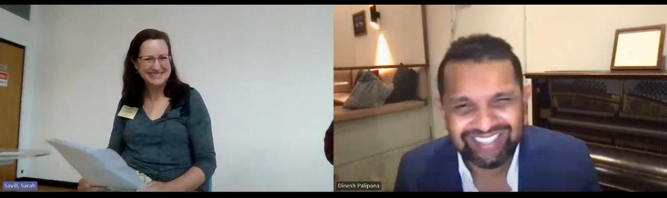

**Figure 2:** Session one facilitator, Lisa Burnette, interviewing keynote speaker, Dr Dinesh Palipana from Gold Coast University Hospital via MS Teams

* **Panel discussion - Supporting people with hidden disability in the workplace**

Led by Neurokin Lead Sarah Savill and featuring Kathryn Boon, Erin Mansell, Dr Ettore Guaia, and Holly Bootsma.

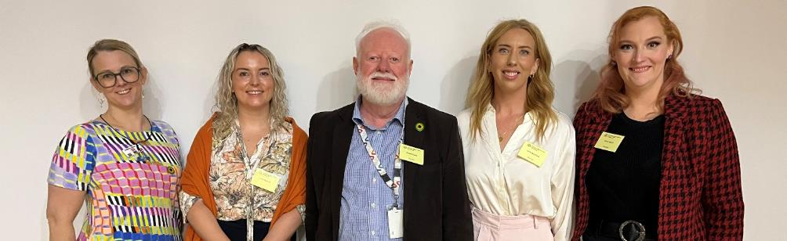

**Figure 3:** Panel members. Left to right: Kathryn Boon, Erin Mansell, Dr Ettore Guaia, Holly Bootsma, and Sarah Savill.

* **Disability Inclusive Workplace Innovation Lab**

Led by Chloe Binder and supported by Zoe Warwick, where participants discussed practical opportunities to support staff with disability to thrive in the workplace.

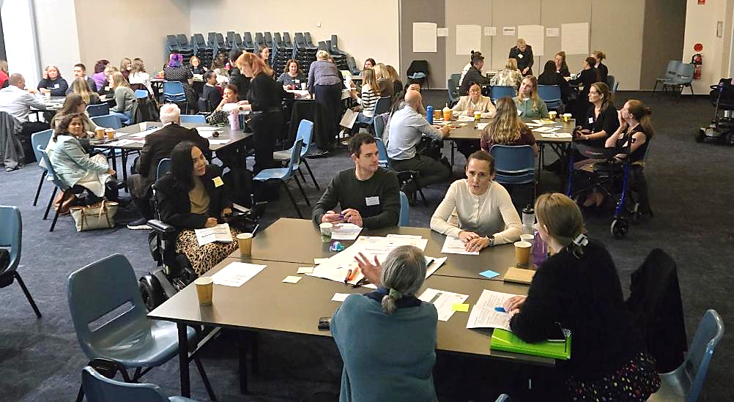

**Figure 4:** Groups workshopping the topics during the Innovation Lab.

The hybrid event allowed people to attend in person or online for the keynote speech and panel discussion components. The afternoon workshops were held for in-person attendees only.

The Disability Health Network (DHN) worked in partnership with the SDAN organising committee to plan and run the conference. A list of organising committee members can be found at the end of the event program:

<https://www.health.wa.gov.au/~/media/Corp/Documents/Health-for/Disability/2025-SDAN-Conference-Program.pdf>

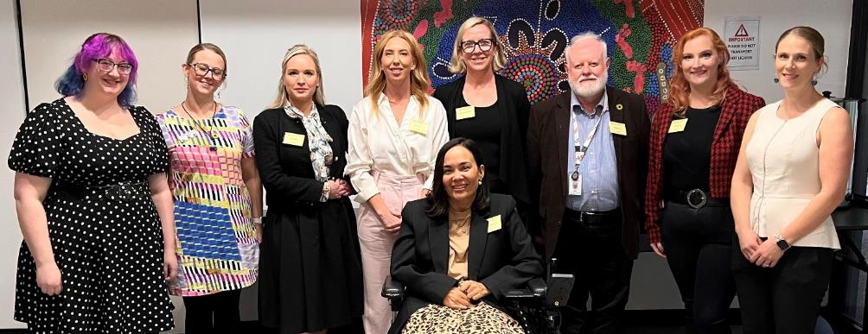

**Figure 5:** Some members of the organising committee and panel. From left to right: Evie Anderson, Kathryn Boon, Chloe Binder, Holly Bootsma, Stephanie Coates, Dr Ettore Guaia, Sarah Savill, Whitney Darlaston-Jones. In front: Jocelyn Franciscus.

## Key action areas, challenges, and opportunities

### Context

During the afternoon Innovation Lab, participants at 8 facilitated tables, focused on 4 discussion topics, across the two domains of hidden disability and physical disability (see list below).

Discussion topics:

1. Leadership and advocacy.
2. Physical space.
3. Legal, ethical, compliance and policy.
4. Communication, technology, and tools visible disability.

Participants were asked to consider the relationship between three key elements:

* What is the unmet need?
* What challenges does it create?
* What accommodations could support?

Discussions from the Innovation Lab have been themed and summarised into the points below, including key areas for action to improve inclusion. Links to existing resources and information about disability employment can be found here:

<https://www.health.wa.gov.au/~/media/Corp/Documents/Health-for/Disability/2025-Disability-Inclusion-Workforce-Resources.pdf>

### 1. Leadership and Advocacy

**Challenges and barriers**

* Understanding disability
  + A limited understanding of disability, the social model of disability, and the benefits of inclusive workplaces has the potential to lead to bullying, social isolation, adjustments being rejected, or inappropriate processes being followed in different workplaces.
* Managerial and executive training
* Managers and leaders receive limited formal training in leadership, inclusion, and disability support.
* Quarantining time and prioritising professional development can be challenging (particularly for leaders in clinical settings).
* Executive champions
* Practical and demonstrable executive commitment to championing disability inclusion remains limited, hindering meaningful cultural change.

“This silence comes at a personal cost and a cost for the system; when disclosure feels dangerous, inclusion becomes impossible.”

– Dr Ettore Guaia

**Key actions**

* Culture change
  + Executives to consistently model inclusive behaviours.
  + Normalise open conversations about adjustments during recruitment, onboarding, and professional development and review discussions.
  + Normalising open conversations about workforce inclusion during team and staff meetings.
  + Authentically celebrate and support leaders with disability.
* Education and training
  + Standardise the use of co-designed training on diversity and inclusion as component of induction and onboarding for people in managerial or leadership roles.
  + Implement the Queensland Health’s ‘See me. Hear me. Respect me.’ Campaign across HSPs and the department to reduce stigma around disability: <https://www.health.qld.gov.au/public-health/groups/people-with-disability/see-me-hear-me-respect-me-campaign> (contact [Disability Health Network](mailto:healthpolicy@health.wa.gov.au?subject=Disability%20Health%20Network:%20Deed%20of%20License%20QLD%20Health%20disability%20campaign) for information on the Deed of License).

“How many people with hidden disability are in decision making roles in WA Health? Inclusion is not just about support at the individual level, it is about changing the system so that people with lived experience help shape the policy, teams, and priorities from top down.”

– Dr Ettore Guaia

### 2. Physical Space

**Challenges and barriers**

* Staff with disability are often excluded from decisions on workplace design and upgrades (e.g. elevator upgrades and consultation on size and location of buttons).
* Accessibility is sometimes deprioritised in favour of financial or ‘majority rules’ considerations.
* Many buildings are outdated and there is inconsistent accessibility across WA Health sites, restricting employment options for some staff.
* For example: flight decks in clinical areas accessed via steps, manual doors, limited access to ergonomic equipment, limited access to quiet spaces, inappropriate number and location of ACROD bays.
* Workspaces often provide limited sensory flexibility and are not suited to varied access needs, impacting wellbeing and productivity.
* For example: no control over lighting or temperature, standardised furniture, open plan offices with no quiet work areas.

“Many of us has experienced, as soon as you say you have a particular condition or disability, people automatically assume what you can’t do. What part of that condition, before they have even met you, is not suitable to their workplace and their workload.”

– Erin Mansell

**Key actions**

* Managers and executive take responsibility for identifying opportunities to improve accessibility as a component of staff safety.
* Establish designated sensory spaces at all WA Health sites with clear guide for use.
* Consult staff with disability on all builds and refurbishments.
* Conduct regular accessibility and safety audits, using feedback from staff with disability to guide improvements.
* Standardise adjustable lighting where possible and move towards lighting sources that mimic natural light more closely.
* Offer a range of ergonomic equipment and processes where necessary, including but not limited to desk lighting and noise cancelling headphones.[4]
* Encourage teams to regularly discuss physical and psychosocial accessibility.

### 3. Legal, Ethical, Compliance, and Policy

**Challenges and barriers**

* Limited consistency and sharing across HSPs and the department in policies, information and equipment.
* Challenge for staff moving positions between HSPs.
* Existing procedures are often compliance-driven and provide limited practical guidance for inclusive conversations and actions.

“Inclusion means… making workplace adjustments the norm, not the exception.”

– Dr Ettore Guaia

**Key actions**

* Develop a statewide co-designed DAIP with local action plans from all HSPs.
* Introduce key performance indicators for leaders on:
  + Safety (particularly psychosocial safety).
  + Completed training on diversity and inclusion.
  + Implementation of strategies to support diversity, inclusion, and psychosocial safety.
* Tools and resources:
  + Introduce and normalise the use of personal care plans for all staff (e.g. [Template – Workplace Preferences – Australian Public Services Commission](https://www.apsc.gov.au/sites/default/files/2021-02/work_preferences_template.pdf)).
  + Standardise co-designed inclusive recruitment tools and processes.
  + Co-design guidance for staff and managers on reasonable adjustments.
  + Implement the Public Sector Commission resources in standard processes for recruitment, manager training, and onboarding (see list of resources here: <https://www.health.wa.gov.au/~/media/Corp/Documents/Health-for/Disability/2025-Disability-Inclusion-Workforce-Resources.pdf>).
* Workforce processes
  + Include Section 66R of the *Equal Opportunity Act* (preferential appointment of successful candidates with disability) in all WA Health job advertisements.
  + Prioritise flexible work arrangements for all staff where industrial relations agreements allow.
  + Appoint Workforce Disability Liaison Officers using Section 66S(c) of the *Equal Opportunity Act* (quarantining positions specifically for people with disability) to support staff on issues related to disability inclusion.
  + Allow flexibility in job design through adjustments to JDFs and role descriptions, where possible.

“How do we as an organisation embrace that culture of ‘yes, we can’ versus there has to be X, Y, and Z to go through before we can?”

– Holly Bootsma

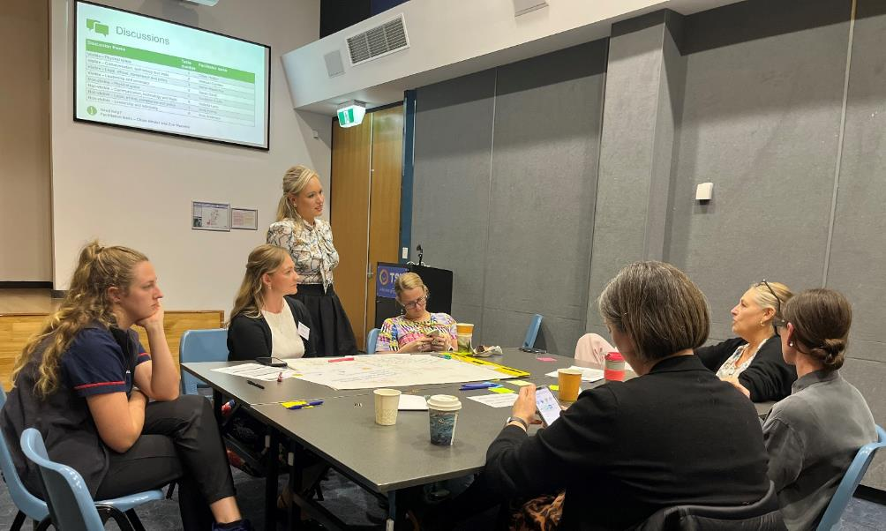

**Figure 6:** Conference Innovation Lab lead, Chloe Binder, supporting conversations on a table.

### 4. Communication, Technology, and Tools

**Challenges and barriers**

* Equipment and technology often have limited accessibility, reducing the ability of staff with disability to work effectively.
* Limited system integration between HSPs and the inconsistency in understanding of disability across the workforce places the burden on individuals to repeatedly explain and request their adjustments.

“It’s about empowering a person’s strengths a little bit better and then supporting the things that are a little bit trickier, and I think navigating it with nurture.”

– Holly Bootsma

**Key actions**

* Purchase accessibility tools (e.g. voice-to-text, AI notetaking) that can be used across WA Health.
* Provide safe spaces for staff with disability to access support and advice.
* Implement the Hidden Disability Sunflower initiative across all WA Health entities.

1. Public Sector Commission (2023) People with Disability Action Plan to Improve WA Public Sector Employment Outcomes 2020–2025. Accessed from <https://www.wa.gov.au/government/publications/people-disability-action-plan-improve-wa-public-sector-employment-outcomes-2020-2025>
2. Public Sector Commission (2025) Western Australian public sector workforce report: March 2025. Accessed from <https://www.wa.gov.au/government/publications/western-australian-public-sector-workforce-report-march-2025>
3. Diversity Council Australia (2024) Inclusion@work index. 2023–2024: Mapping the state of inclusion in the Australian workforce. Accessed from <https://www.dca.org.au/wp-content/uploads/2023/10/The-Case-for-Inclusion@Work-2023-2024.pdf>
4. Ergonomics is more than chairs and keyboards. It is the complete assessment of workplace setup, equipment and processes to ensure a person can complete their work in comfort, and without fatigue or injury. Thus it is inclusive of lighting, sound, equipment, and work practices.