WA Disability Health Framework 2015-2025
Improving the health care of people with disability

Overview (option 1: generic framework information)
The WA Disability Health Framework 2015-2025: Improving the health care of people with disability (the Framework) was developed by the Disability Health Network as WA Health’s response to the World Health Organisation Global Disability Action Plan 2014-2021 and the Australian Government National Disability Strategy 2010-2020.
The Framework provides direction for the WA health system and its partners on policy development and service delivery to achieve improved health outcomes for people with disability. It outlines priority areas for improving the health outcomes of people of any age living with disability and encompasses the spectrum of diversity. This includes Aboriginal people and people from culturally and linguistically diverse backgrounds. It applies to a person over their life course; starting with child and family centred practice through to palliative care and end of life approaches.
The Framework adopts the social model to define disability. This acknowledges that the physical, attitudinal, communication and social environment must change to enable people living with impairments to participate equally in society.
There is a strong rationale for a disability health focus which includes health disparities that exist for people with disability, acknowledgement that people with disability are best placed to input to the design, planning and delivery of their supports and services to ensure barriers to health care are removed, legislative obligations and local, state and national strategic directions.
The vision of the Framework is an inclusive Western Australian health system that empowers people with disability to enjoy the highest attainable standard of health and wellbeing throughout their life.

Overview (option 2: shorter version)
The WA Disability Health Framework 2015-2025 outlines a vision for an inclusive Western Australian health system that empowers people with disability to enjoy the highest attainable standard of health and wellbeing throughout their life.
In order to achieve this vision, the Framework provides goals and guiding principles for the WA health system when developing policy, implementing services and making decisions regarding the provision of health care. The Framework presents four system wide priority areas for action:
- understanding and recognition,
- health and wellbeing,
- workforce capability and
- inclusive health care.
Addressing the priority areas and implementing improvement initiatives effectively and sustainably requires an understanding of system influencers. These can be enablers of change, or barriers, along with broader contexts outside the scope of this Framework. Key system influencers are provided in the Framework.

Framework in action
Since its launch in 2016, the Framework has been used by health service providers to inform key projects such as the Para quad Redevelopment Plan, Disability Liaison Project and informed the implementation of Disability Access and Inclusion Plan.
The Framework has been influential in shaping training and development activities for clinical and non-clinical staff and facilitated conversations with a range of stakeholders working to empower people with disability to be partners in their health care delivery.
The Framework has been referenced in several key Department of Health documents including the WA Health Promotion Strategic Framework 2017–2021 and the recently developed framework, You Matter: engaging with consumers, carers, community and clinicians in health.
The Disability Health Network has commenced an intensive Engagement Plan to promote the Framework that will culminate in a celebration for Disability Awareness Week in December 2017. An evaluation of this activity is planned.
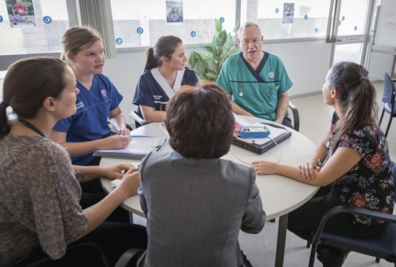

Health disparities/Framework rationale
In 2012, it was estimated that 18.5 per cent of the Australian population had a disability. This number is projected to continue increasing due to the ageing population and increases in chronic health conditions.
Despite the overall improvement in the general population’s health, the gap between the health of Australians with disability and those without disability remains large. Current data from the Australian Institute of Health and Welfare suggests that almost half of people aged 15–64 with severe or profound disability reported poor or fair health compared with five per cent for those without disability. People with disability in this group are three times as likely as the general population to experience three or more chronic health conditions and eight times more likely to experience mental health problems. They are less likely to participate in exercise, more likely to smoke and more likely to experience obesity than the general population.
An Australian Institute of Health and Welfare study found that people with severe or profound disability, aged 15 to 64 years, in comparison to people without disability were 10 times more likely to have check-ups with general practitioners, 3.5 times more likely to consult specialist doctors and 5 times more likely to consult specialist doctors and other health professionals like occupational therapists, social workers and welfare workers.
Consultations with people with disability, their families and carers consistently highlighted the difficulties experienced accessing health care that met their needs. The following barriers were identified:
- poor information flow or disregard for information provided, particularly at transition or transfer of care,
- lack of awareness, understanding and knowledge of disability by healthcare providers, including communication skills,
- health information resources not provided and distributed in user-friendly ways,
- uncoordinated or poorly planned transition of care between health and disability providers or the community and
- lack of knowledge on healthcare needs and services available for individuals, carers and disability service providers to be able to advocate.

