Hospital Stay Guidelines: Community consultation report 2022
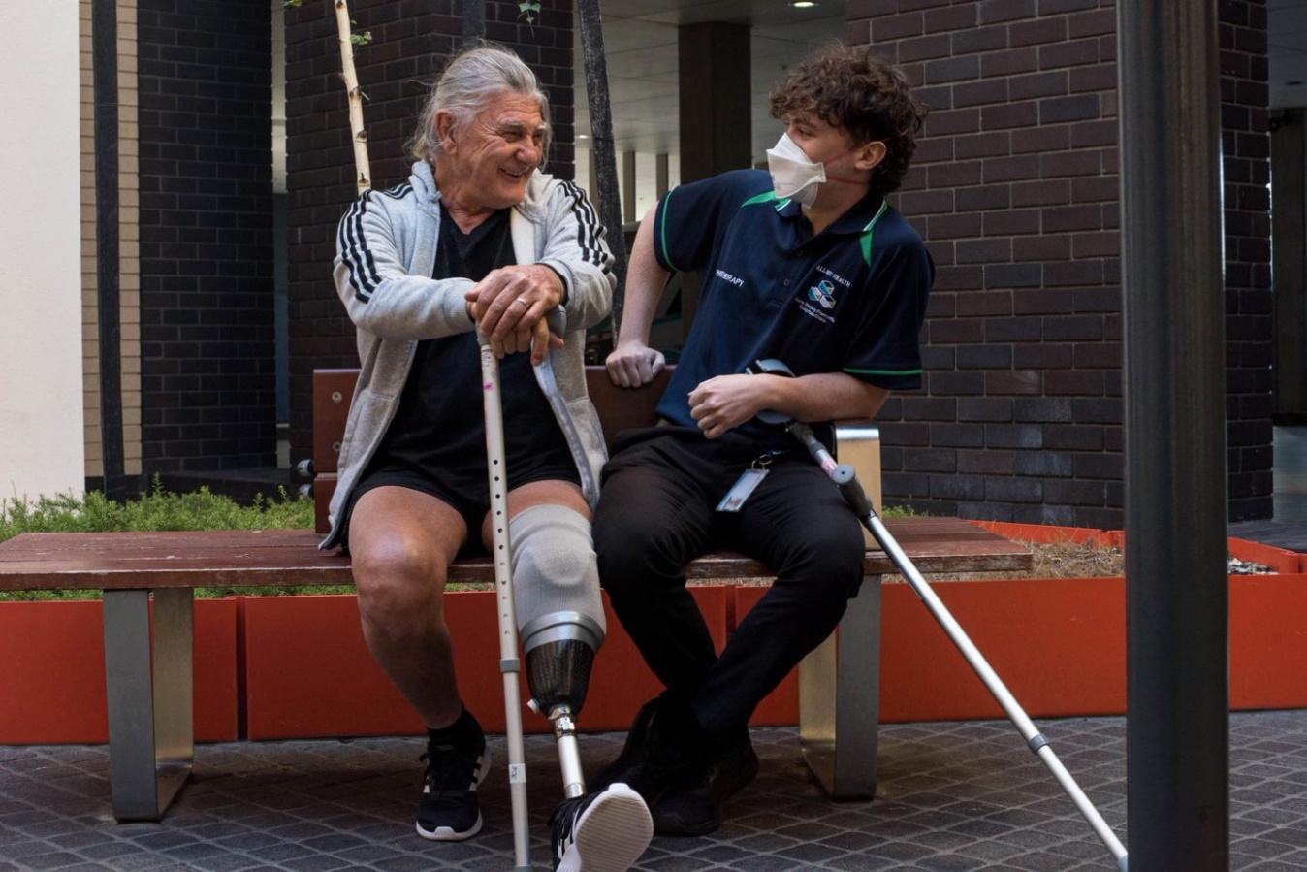
Acknowledgement of Country and People
WA Health acknowledges the Aboriginal people of the many traditional lands and language groups of Western Australia. It acknowledges the wisdom of Aboriginal Elders both past and present and pays respect to Aboriginal communities of today.
Readers are warned that this document may contain images of people who have deceased since the time of publication.

© Western Australian Department of Health (2022)
All information and materials in this document are protected by copyright. Copyright resides with the State of Western Australia. Apart from any use permitted by the Copyright Act 1968 (Cth) the information in this document may not be published, or reproduced in any material whatsoever, without express permission of Western Australian Department of Health.

Suggested citation
Western Australian Department of Health. Hospital Stay Guidelines, community consultation report 2022. Perth, WA: Health Networks, Western Australian Department of Health; 2024.

Important disclaimer
All information and content in this material is provided in good faith by the Western Australian Department of Health and is based on sources believed to be reliable and accurate at the time of development. The State of Western Australia, the Western Australian Department of Health, and their respective officers, employees, and agents do not accept legal liability or responsibility for the material, or any consequences arising from its use.

Contact information
For further information, contact the Western Australian Department of Health at (08) 9222 0200 or at healthpolicy@health.wa.gov.au.

The Disability Health Network would like to thank all individuals and organisations that participated and contributed to the revision and co-designed update to the Hospital Stay Guidelines, including promoting the consultation through their extended networks and providing feedback. The process of harnessing collective wisdom and expertise has been instrumental in updating the guidelines.

Contents
1 Executive summary 1
2 Background 1
2.1 Consultation process 2
3 Community consultation 3
3.1 Feedback from the online consultation survey 4
3.1.1 A guide for people with disability, family, friends and carers 5
3.1.2 A guide for disability service providers 7
3.1.3 A guide for hospital staff 8
3.2 Feedback from the email submissions 10
4 Consultation meetings 11
5 Final guidelines 11
6 Appendix A: Copy of the online consultation survey 13

List of figures
Figure 1: Community consultation process 3
Figure 2: Information provided for people with disability, families and carers 5
Figure 3: Usefulness of the guide for people with disability, families, friends and carers 6
Figure 4: Information for Disability Support Services and support workers 7
Figure 5: Usefulness of the guide for disability service providers 8
Figure 6: Information for Hospital Staff 9
Figure 7: Usefulness of the guide for hospital staff 10

Executive summary
The aim of the Hospital Stay Guidelines (guidelines) is to improve the hospital experience and healthcare outcomes for people with disability. The Hospital Stay Guideline for Hospitals and Disability Service Organisations was developed by the Disability Health Network (DHN) in 2016 and following changes in healthcare for people with disability, was reviewed and updated through a series of consultation with key stakeholders.
This review recommended that the 2016 Hospital Stay Guideline for Hospitals and Disability Service Organisations be expanded into 3 sections to improve the interface between consumers, disability service providers and hospital staff.
The updated draft guidelines comprised the following:
- A guide for people with disability, families, friends, and carers
- A guide for disability service providers
- A guide for hospital staff
The draft guidelines opened for public consultation for 8 weeks from December 2021 to January 2022. A total of 32 responses were received via an online survey and 5 direct email responses were received. The feedback indicated that further work needed to be undertaken to ensure that the guides for people with disability, families, friends and carers and disability service providers were fit for purpose. As such, an external consultant with knowledge and expertise in the disability and community sector was contracted to engage with the community and incorporate feedback into the guides. The updated guidelines were developed and published in November 2022.

Background
The guidelines were developed by the Health Networks Directorate, Clinical Excellence Division, Department of Health WA. The aim of the guidelines is to improve the hospital experience and healthcare outcomes for people with disability. The Hospital Stay Guideline for Hospitals and Disability Service Organisations was developed by the DHN in 2016 and outlined a best practice approach for disability service organisations and hospitals in managing the hospital experience of people with disability.
Following the roll out of the National Disability Insurance Scheme in Western Australia and changes in healthcare for people with disability, it was vital that the Hospital Stay Guideline for Hospitals and Disability Service Organisations was current and relevant for all people with disability. As such, an extensive co-design was undertaken to review and update the guideline. During this process, the name of the guideline changed from the “Hospital Stay Guideline for Hospitals and Disability Service Organisations” (2016 guideline) to the “Hospital Stay Guidelines” (2022 guidelines).
The process undertaken aligns with the departments progress towards achieving key policies and strategies including:
Sustainable Health Review
- Recommendation 4: Commit to new approaches to support citizen and community partnership in the design, delivery and evaluation of sustainable health and social care services and reported outcomes.
- Recommendation 15: Improve the interface between health, aged care, and disability services to enable care in the most appropriate setting and to ensure people do noy fall between the gaps.
WA Disability Health Framework 2015-2025
- An inclusive Western Australian system empowers people with disability to enjoy the highest standard of health and wellbeing throughout their life.
- Provide direction to WA Health and its partners on policy development and service delivery to achieve improved health outcomes for people with disability.
A summary of the process to review and update the 2022 guidelines is outlined in Figure 1 on the following page. This report summarises the feedback that was received from the broad community consultation of the draft 2022 guidelines (step 3 of the above process).

Consultation process
Step 1 involved the DHN partnering with the WA National Disability Service (NDS) to review the 2016 guideline. This was a deliverable of the ‘Ready to Go Home’ project, of which the NDS and Department of Health partnered on, to address delays to discharge for people with disability, improve the hospital experience for people with disability and improve the interface between health and disability services.
From this review, it was recommended that the 2016 guideline be expanded into 3 sections and tailored to the needs of each stakeholder group to improve the interface between consumers, disability service providers and hospital staff.
Step 2 involved expanding the 2016 guideline into the following 3 sections:
- A guide for people with disability, families, friends, and carers
- A guide for disability service providers
- A guide for hospital staff
Developmental Disability WA and a WA Health staff member with experience in working with people with disability were funded to update the content and create drafts for the 2022 guidelines. This involved collaborating with key stakeholders, including people with lived experience of disability, carers, disability support services and hospital staff, to ensure the content was accurate. The draft 2022 guidelines were completed in November 2021.
Step 3 invited broad community input through publishing the draft 2022 guidelines for public consultation. This was opened on 3 December 2021 at the DHN and South Metropolitan Health Service International Day of People with Disability event and closed on 28 January 2022.
A total of 32 responses were received via an online survey and 5 direct email responses were received. Meetings were also held with key stakeholders for their feedback.
The feedback indicated that further work needed to be undertaken to ensure that the 2022 guides for people with disability, families, friends and carers and disability service providers were fit for purpose.
Step 4 involved contracting an external consultant with lived experience, knowledge and expertise in the disability and community sector to incorporate the feedback from the consultation and refine the guides.
Step 5 involved developing and publishing the updated 2022 guidelines based on the feedback received from the public consultation. The 2022 guidelines were launched by the DHN co-leads, Stephanie Coates and Jocelyn Franciscus, at International Day of People with Disability event on 30 November 2022 hosted by the DHN and North Metropolitan Health Service.
Figure 1: Community consultation process
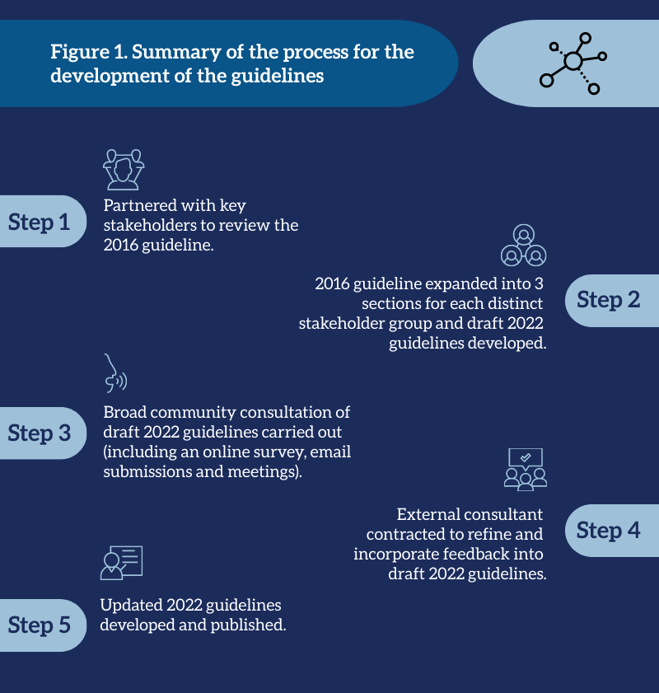

Community consultation
In late 2021 and early 2022, broad community consultation on the draft 2022 guidelines was undertaken by the Health Networks Directorate with a range of stakeholders. The online consultation for the draft 2022 guidelines opened for 8 weeks from 3 December 2021 to 28 January 2022. The aim of this consultation was to:
- raise awareness of the 2016 guideline and to begin promoting the revised and updated 2022 guidelines
- involve a broad range of stakeholders in the revision and update of the 2022 guidelines to promote a sense of ownership of the guidelines and its implementation
- reconnect with the stakeholders that participated in the consultation of the initial 2016 guideline
- confirm the 2022 guidelines are fit for purpose and provide useful and relevant information for the intended target audience.
This community consultation involved:
- an online consultation survey managed by the Health Networks Directorate
- an opportunity for the community to make email submissions
- an opportunity for stakeholders to participate in consultation meetings.
A total of 32 responses were received via an online survey and 5 direct email responses were received. Several consultation meetings were held with stakeholders for their feedback. This report details the feedback received on the draft 2022 guidelines from the online consultation survey, email submission and consultation meetings.

Feedback from the online consultation survey
The main aim of the online consultation survey was to confirm that the 2022 guidelines are fit for purpose and provide useful and relevant information for the intended target audience. A copy of the survey is provided in Appendix A. Citizen Space was used to design the survey and collect responses. A copy of the survey in an alternative format was available on request.
The survey was launched at the DHN’s International Day of People with Disability event on 3 December 2021 and attendees were encouraged to complete it. The event was attended by people with lived experience of disability, carers, disability service providers, support workers, peak disability bodies, hospital staff and other government departments.
A link to the survey inviting individuals or organisations to participate was distributed via Health Happenings and Health Point and the Health Networks Bulletin. Emails were also sent to the selected stakeholders:
- people with disability and their carers and families
- disability service providers and support workers
- clinicians and hospital staff across public and private settings
- people working/volunteering/advocating within the disability sector
- peak disability bodies
- advocacy organisations.
The survey was open for 8 weeks and closed 28 January 2022. Data from the survey was downloaded from Citizen Space. Quantitative data was analysed using Microsoft Excel. Qualitative data was analysed using thematic analysis to identify recurring themes occurring within the respondents’ feedback.
A total of 32 responses were submitted via the online survey. Most respondents worked for a hospital (25%) or community-based service provider (25%), with 75% of all respondents providing their own individual views.
Prior to the survey, 56% of respondents were not aware of the 2016 guideline. Of those that were aware of the 2016 guideline, respondents (n=15) indicated that the guideline was useful in the delivery of health care for people with disability and supporting people with disability when they are admitted to hospital.
A summary of the feedback for each guide is provided below. Please note that not all respondents answered the questions for each guide. Due to privacy and confidentiality considerations, quotes have been paraphrased and are representative of the collective feedback.

A guide for people with disability, family, friends, and carers
Of those who responded, most agreed that the information in the guide for people with disability, family, friends and carers provided guidance on interacting with hospital staff (76%), their hospital stay (76%) and discharge from hospital (68%) and that the guidance was appropriate for people with disability (59%) (Figure 2).
Figure 2: Information provided for people with disability, families, and carers

When asked what further information could be included to assist people with disability, responses (n=23) included:
- using clear, plain language in short sentences
- altering the tone of the guide and addressing it to people with disability
- explaining the roles and responsibilities disability service providers and hospital staff when a person with disability is in hospital
- including information on National Disability Insurance Scheme (NDIS) funded supports whilst a person with disability is in hospital
- adding a glossary for specific concepts.
Of those whose responded, most agreed that the guide is easy to understand (76%), clear and concise (64%), provides appendices that are useful (80%) and is useful for people with disability, families and carers (72%) (Figure 3).
Figure 3: Usefulness of the guide for people with disability, families, friends, and carers

Eighty-four per cent of respondents (n=25) indicated they would prefer the guide as both an online and hard copy version. When asked for additional feedback and how the guide for people with disability, families, friends, and carers could be improved, responses (n=18) included:
- including infographics, diagrams, and pictures to explain processes
- making the content more concise.

A guide for disability service providers
Of those whose responded, most agreed that the information in the guide for disability service providers provided guidance about patients presenting to the Emergency Department (77%), preparing patients for hospital admission (78%) and preparing patients for discharge from hospital (70%) (Figure 4).
Figure 4: Information for Disability Support Services and support workers

When asked what further information could be included to assist support services, responses (n=18) included:
- including information on behaviour management and support
- tailoring the language of the guide for the audience (noting that many support workers have English as a second language and an education level to Year 10)
- including more information on supported decision-making
- including information on NDIS funded supports whilst a person with disability is in hospital
- emphasising the importance of support workers having the necessary medical information for the person they support.
Of those whose responded, most agreed that the guide is easy to understand (78%), clear and concise (79%), provides appendices that are useful (83%) and is useful for disability support services (69%) (Figure 5).

Figure 5: Usefulness of the guide for disability service providers

Eighty-six per cent of respondents (n=23) indicated they would prefer the guide as both an online and hard copy version.
When asked for additional feedback and how the guide for disability service providers could be improved, responses (n=12) included:
- re-formatting paragraphs to tables or flow charts and having clear headings
- aligning the guide with the quality and safeguard framework that disability service providers work under
- changing the communication scripts to include resources on how to communicate with people with other disabilities.

A guide for hospital staff
Of those who responded, most agreed that the information in the guide for hospital staff provided guidance about gathering background information (88%), working collaboratively (80%), hospital staff roles and responsibility during admission (84%), disability service providers roles and responsibility during admission (75%) and discharge planning (84%) and that the guide had useful real-life examples through patient stories (69%) (Figure 6).
Figure 6: Information for Hospital Staff

When asked what further information could be included to assist hospital staff, responses (n=18) included:
- explaining the roles and responsibilities of people with disability and carers, disability service providers and hospital staff when a person with disability is in hospital
- including information on NDIS funded supports whilst a person with disability is in hospital
- using clear and simple language
- having more complex real-life examples and a long-stay example
- identifying potential discharge barriers
- mentioning the potential need for additional time for activities, such as communication.
Of those who responded, most agreed that the guide is easy to understand (84%), clear and concise (71%), is relevant for their hospital/site(s) (54%), provides appendices that are useful (79%) and is useful for hospital staff (58%) (Figure 7).
Figure 7: Usefulness of the guide for hospital staff

Eighty-seven per cent of respondents (n=24) indicated they would prefer the guide as both an online and hard copy version.
When asked for additional feedback and how the guide for hospital staff could be improved, responses (n=15) included:
- providing an online training module for hospital staff
- including key points at the beginning or end of sections to improve useability
- re-formatting paragraphs to tables or flow charts and having clear headings
- highlighting the importance of having key disability-related information about the person with disability stored and using it during staff handover.

Feedback from the email submissions
The submission of feedback via email during the consultation period of the draft 2022 guidelines was not actively promoted. Five email submissions for the draft 2022 guidelines were received from organisations (n=2), Department of Health staff (n=2) and a consumer (n=1).
The main themes that emerged from these submissions included:
- more succinct information regarding guide dog management in hospital, advance care planning, supporting sensory needs, supported decision-making and the health and disability interface
- adding information on unplanned hospital admissions
- changing the language to address people with disability as opposed to their supports
- emphasising the need for hospital staff to support with assistive technology, equipment, and communication needs
- having a clear definition and description of the rights of carers
- consistent use of terms and a glossary with a description of these terms
- adding information on providing feedback and complaints to hospital service providers
- consistent formatting, including font size and colour.

Consultation meetings
Consultation meetings were held with key stakeholders from August to October 2022 to ensure the final drafts of the 2022 guidelines were fit for purpose. This was also to ensure that information regarding the NDIS was accurate due to recent changes to the scheme. Key stakeholders consulted included a broad spectrum of people with lived experience, disability service organisations and hospital staff.
The main themes that emerged from these submissions included:
- inclusion of friends as a support for people with disability
- clear information about funding for support workers to support a person with disability whilst in hospital

Final guidelines
All feedback from the community consultation online survey, email submissions and meetings were considered by the Health Networks Directorate and DHN co-leads during the development of the final 2022 guidelines.
Alterations to the draft 2022 guidelines based on the feedback received, included:
- amending the language of the guidelines for the specific target audience. This included using Plain English for the guide for people with disability, families, friends and carers and disability service providers
- clear explanations of the roles of responsibilities for people with disability, families, friends and carers, disability service providers and hospital staff when a person with disability is admitted to hospital
- a clear explanation of the rights of carers
- including more information on supported decision-making in the main text
- including information about NDIS funding for support workers to support a person with disability whilst in hospital
- including information on providing feedback and complaints to hospital service providers
- adding in key points at the beginning of sections for a guide for hospital staff
- adding infographics and images to explain processes
- consistent use of terminology and including a glossary with terms for specific concepts
- consistent formatting, including font size and colour, across the guidelines.
The final 2022 guidelines can be accessed on the Disability Health Network webpage.
The final 2022 guidelines were launched by the DHN co-leads, Stephanie Coates and Jocelyn Franciscus, at the International Day of People with Disability event on 30 November 2022. Over 230 people attended, including 110 who attended online. Event attendees included:
- people with disability, families, friends, and carers
- disability service providers
- support workers
- hospital staff
- peak disability and advocacy bodies
- Department of Health and Communities staff.
Following the launch of the 2022 guidelines, an external consultant with knowledge and expertise in the disability and community sector conducted implementation engagement sessions. From these sessions, the development of an implementation plan will support the awareness and use of the guidelines to improve the hospital experience of people with disability and their healthcare.

Appendix A: Copy of the online consultation survey

Overview
The Hospital Stay Guideline for Hospitals and Disability Service Organisations (the Guideline) was developed by the Disability Health Network in 2016 and outlines a best practice approach for disability service organisations and hospitals in managing the hospital experience of individuals with disability.
The WA National Disability Service and the Disability Health Network have partnered to review and update the Guideline. Originally for hospitals and disability service organisations, the updated Guideline has been expanded to include information and resources for people with disability, families, and carers.
The Guideline sets the best practice approach to delivering improved hospital experience for people with disability. The Guideline covers all areas of the health system and disability sector for individuals with a complex disability including:
- attending the emergency department
- attending an outpatient clinic at a hospital or health campus
- being admitted to hospital
- being discharged from hospital back into the community.
The Guideline has three parts for each of the following target groups:
- Part 1: A guide for people with disability, families, and carers
- Part 2: A guide for Disability Service Organisations and support workers
- Part 3: A guide for hospital staff
We invite you to review and provide feedback on the Guideline before Friday 21 January 2022 by clicking "Provide your feedback" below.
To complete this consultation using an alternative format, please contact the Health Networks Directorate by email HealthPolicy@health.wa.gov.au or phone 9222 0202.

Introductory text
You are required to answer questions in the About You page before you submit your response. The remainder of the questions in this survey are optional.
The Hospital Stay Guidelines consist of the following parts:
- Part 1: A guide for people with disability, families, and carers
- Part 2: A guide for Disability Service Organisations and support workers
- Part 3: A guide for hospital staff
You are welcome to provide feedback on one or more parts, or you can skip to the one/s that are of most relevance to you.
Go to the Finish button at the bottom of this page when you are ready to submit your response and select the Submit button on the final page.
You will also have the option to enter an email address to receive a copy of your response.

About You
This section will ask questions to help us understand who is providing feedback on the Guideline.

1. Which of the following best describes your PRIMARY interested in the Hospital Stay Guideline? Please select only one item (Required).
- Person with disability
- Family member of a person with disability
- Carer (unpaid and caring for a person with a disability)
- Employee within the disability sector
- Employee within the public health sector
- Employee within the private health sector
- Volunteer/advocate within the disability sector
- Volunteer/advocate within the health sector
- Prefer not to answer
- Other (please specify below)
Please specify other here: ___________________________________________

2. Which of the following bests describes the type of organisation you work, volunteer or advocate for? Please select only one item (Required).
- Hospital
- Community-based service provider
- Primary care
- Government agency
- Non-government agency
- Charitable organisation
- Educational body
- Have no specific type of organisation
- Prefer not to answer
- Other (please specify below)
Please specify other here: ___________________________________________

3. Is the feedback in this survey your own individual views or does it represent the views of an organisation/group? Please select only one item (Required).
- I am providing my own individual views
- I am providing views on behalf of my organisation/group (please specify below)
Please specify organisation/group here: ________________________________

Below is the front page of the Hospital Stay Guideline for Hospitals and Disability Service Organisations (2016).
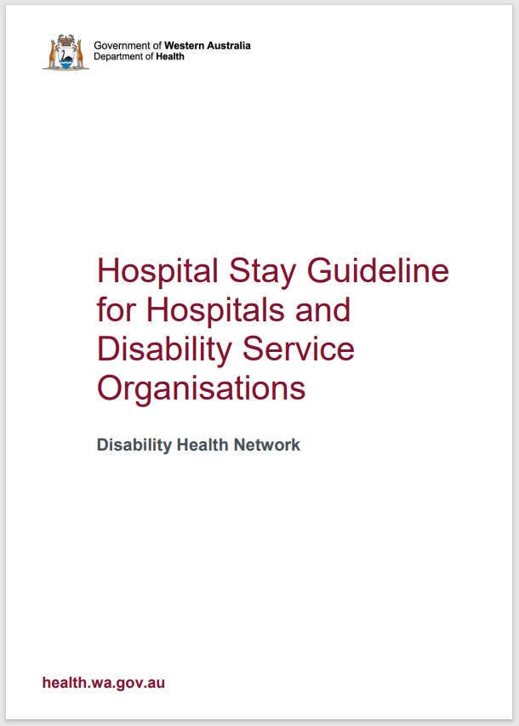
4. Before today, were you aware of the Hospital Stay Guideline for Disability Service Organisations and Hospital Staff (2016)?
- Yes
- No
- Unsure

5. If you have accessed/used the 2016 Hospital Stay Guideline, please describe its relevance to your work:
__________________________________________________________________________________________________________________________________________________________________________________________________________________________________________________________________________________________________________________________________________________________________________________________________________________

Part 1: A guide for people with disability, families, and carers
This section is seeking feedback on Part 1 of the Guideline. Click here to open Part 1 in another window or click on "View Part 1" below. Part 1 has been developed to assist PEOPLE living with disability, families, and carers.
Please note that an Easy Read version of Part 1 will be developed.

1. To what extent do you agree or disagree that information in Part 1 provides PEOPLE with:
 | Strongly disagree | Disagree | Neutral | Agree | Strongly agree | Unable to comment
Guidance on interacting with hospital staff (Please select only one item)
Guidance on their hospital visit or stay (Please select only one item)
Guidance on discharge from hospital (Please select only one item)
Guidance that is appropriate for them (Please select only one item)

2. Thinking about the content in Part 1 what, if any, further information could be included to assist PEOPLE?
__________________________________________________________________________________________________________________________________________________________________________________________________________________________________________________________________________________________________________________________________________________________________________________________________________________

3. To what extent do you agree or disagree that Part 1:
 | Strongly disagree | Disagree | Neutral | Agree | Strongly agree | Unable to comment
Is easy to understand (Please select only one item)
Is clear and concise (Please select only one item)
Provides appendices that are useful (Please select only one item)
Is useful for people with disability, families, and carers (Please select only one item)

4. If you were to use this guideline, would you prefer it as a:
(Please select only one item)
- Hard copy version
- Online version
- Both
- Other (please specify below)
Please specify other here: ___________________________________________

5. Please provide below any additional feedback you may have for Part 1, including how it could be improved for PEOPLE:
__________________________________________________________________________________________________________________________________________________________________________________________________________________________________________________________________________________________________________________________________________________________________________________________________________________

Part 2: A guide for Disability Service Organisations and support workers
This section is seeking feedback on Part 2 of the Guideline. Click here to open Part 2 in another window or click on "View Part 2" below.
Part 2 has been developed to assist Disability Service Organisations and support workers (SUPPORT SERVICES).

1. To what extent do you agree or disagree that information in Part 2 provides SUPPORT SERVICES with:
 | Strongly disagree | Disagree | Neutral | Agree | Strongly agree | Unable to comment
Guidance about patients presenting to the Emergency Department (Please select only one item)
Guidance about preparing patients for hospital admission (Please select only one item)
Guidance about preparing patients for hospital discharge (Please select only one item)

2. Thinking about the content in Part 2 what, if any, further information could be included to assist SUPPORT SERVICES?
____________________________________________________________________________________________________________________________________________________________________________________________________________________________________
3. To what extent do you agree or disagree that Part 2 :
 | Strongly disagree | Disagree | Neutral | Agree | Strongly agree | Unable to comment
Is easy to understand (Please select only one item)
Is clear and concise (Please select only one item)
Provides appendices that are useful (Please select only one item)
Is useful for support services (Please select only one item)

4. If you were to use this guideline, would you prefer it as a:
(Please select only one item)
- Hard copy version
- Online version
- Both
- Other (please specify below)
Please specify other here: ___________________________________________

5. Please provide below any additional feedback you may have for Part 2, including how it could be improved for SUPPORT SERVICES:
__________________________________________________________________________________________________________________________________________________________________________________________________________________________________________________________________________________________________________________________________________________________________________________________________________________

Part 3: A guide for hospital staff
This section is seeking feedback on Part 3 of the Guideline. Click here to open Part 3 in another window or click on "View Part 3" below.
Part 3 has been developed to assist HOSPITAL STAFF with caring for people with disability.

1. To what extent do you agree or disagree that information in Part 3 provides HOSPITAL STAFF with:
 | Strongly disagree | Disagree | Neutral | Agree | Strongly agree | Unable to comment
Guidance about gathering background information (Please select only one item)
Guidance about working collaboratively (Please select only one item)
Guidance about staff roles and responsibilities during admission (Please select only one item)
Guidance about service providers roles and responsibilities during admission (Please select only one item)
Guidance about discharge planning (Please select only one item)
Useful real-life examples through patient stories (Please select only one item)

2. Thinking about the content in Part 3 what, if any, further information could be included to assist HOSPITAL STAFF?
__________________________________________________________________________________________________________________________________________________________________________________________________________________________________________________________________________________________________________________________________________________________________________________________________________________

3. To what extent do you agree or disagree that Part 3 :
 | Strongly disagree | Disagree | Neutral | Agree | Strongly agree | Unable to comment
Is easy to understand (Please select only one item)
Is clear and concise (Please select only one item)
Is relevant for my hospital/site(s)
(Please select only one item)
Provides appendices that are useful (Please select only one item)
Is useful for hospital staff (Please select only one item)

4. If you were to use this guideline, would you prefer it as a: (Please select only one item)
- Hard copy version
- Online version
- Both
- Other (please specify below)
Please specify other here: ___________________________________________
5. Please provide below any additional feedback you may have for Part 3, including how it could be improved for HOSPITAL STAFF:
__________________________________________________________________________________________________________________________________________________________________________________________________________________________________________________________________________________________________________________________________________________________________________________________________________________

This document can be made available in alternative formats
on request for a person with disability.
© Department of Health 2024
Copyright to this material is vested in the State of Western Australia unless otherwise indicated. Apart from any fair dealing for the purposes of private study, research, criticism, or review, as permitted under the provisions of the Copyright Act 1968, no part may be reproduced or re-used for any purposes whatsoever without written permission of the State of Western Australia.

